Approval Signatures:

Department | Name | Signature | Date
QA | Andrea Miller
Clinical | Megan McNamee
Exec | Nancy Rizzo
IS | Andrew Mason

- Purpose

This document is intended to provide a protocol for use in verifying and validating the Clinical Trial Data Collection Web Form version 3.0. This protocol is intended to provide a method for conducting the testing as well as to be used as a formal record of the validation activities.

- Scope

This protocol is intended to be used to fully validate the Clinical Trial Data Collection Web Form version 3.0. The protocol can be executed in total or in part. Any deviation from performing all sections of this validation must be resolved with appropriate written justifications prior to final approval of the validation report.

- Definitions

N/A

- Responsibilities

User | - Complies with the policy and procedure.  - Ensures the most current version of this document is used when referenced.
Departmental Management | - Ensures departmental personnel are properly trained before using this policy or procedure.  - Provides oversight to the validation process and ensures that all quality system requirements are met.
Quality Assurance | - Monitors the implementation and effectiveness of this document.  - Audits to ensure compliance with the referenced procedures

- Policy

  - This protocol is intended to be updated for any changes made to the web form such that the instructions provide a comprehensive test to demonstrate whether the web form meets the intended use.
  - Follow the instructions provided within this protocol as written. Any deviations from the written protocol will be recorded on Attachment A, Deviations from Protocol.

    - An individual will be assigned responsibility from the Validation Team to oversee the execution of the protocol. This validation designee will review each deviation as documented prior to moving forward in the validation process.
    - The validation designee will be required to determine whether the deviation requires formal documentation through EPIC’s Deviation procedure or if the deviation is minor enough to warrant documentation only.
    - Upon completion of the protocol, the Validation Team has the responsibility to review all deviations recorded to determine whether or not they significantly impact the protocol/validation process. Any deviation deemed significant will be handled through EPIC’s Deviations procedure.
    - The individual performing the validation protocol will complete each column of Attachment A for all deviations from the written protocol prior to moving forward. The validation designee will review each deviation prior to moving forward in the validation process. This review is indicated by documenting a signature and date in the Review column of the Deviations from Protocol worksheet located in Attachment A.
    - The validation designee should be aware during the execution of this validation protocol that the intention is to validate all functionality of the web form. If at any time a portion of the web form is identified as not being challenged, notify the validation team immediately and document the omission on the non-conformances worksheet.

  - The written protocol is intended to capture the steps needed to properly challenge each web form function. However, given the evolving nature of web form development, the instructions may not be 100% accurate. Therefore, any minor deviation from the written instructions will be corrected in writing during the execution of the validation protocol. These corrections will be reviewed by QA as a part of the validation analysis. The review will determine appropriate corrective and preventive action for any deviations notes.

  - Record the results of each validation step by initialing and dating in the space provided. If the characteristic cannot be verified, record a reference number on the protocol and the Non-Conformances Worksheet (Attachment B) and describe the failure in a specific and complete manner by completing all columns on the Non-Conformance Worksheet. Some validation steps ask the validation designee to record the results side-by-side. In these cases, record initials and date on each side of the slash mark after validating each step as instructed.

  - The web form used for validation purposes is a copy of the database and is not the actual database used in the Clinical Trial. The copy site functions exactly the same as the original site and contains the exact same software code.

  - All verification and/or validation documentation created will be labeled with the version number, the Sample # (indicated in the protocol) and the initials and date of the individual performing the verification/validation step.

- Procedure

  - Research Assistant Functions

    - Log In function. This window provides the user with a method to enter their user name and password in order to access the web form application.

Go to http://newct.epicdiagnostics.com

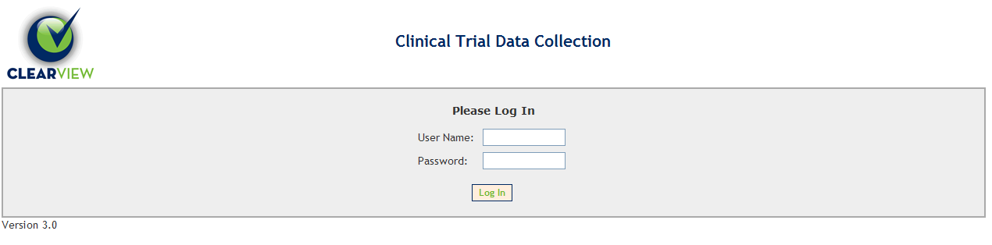

Record the version number. This number is listed below the bottom left corner of the Log In box.

Record the version number here: ________________________

Click in the User Name box and enter “ra1”. Click in the password box and enter “ra1”. Click the Log In button. Verify that a red message appears saying “Invalid Login,” the User Name box contains “ra1” and the Password box is empty.

Verified Not Verified Non-Conformance Ref. No.

Click in the User Name box and enter “ra1”. Click in the password box and enter “ra183pwd#”. Click the Log In button. Verify that the Main Menu with View Master Key Database, Search Subject Records and Logout links appears as below:
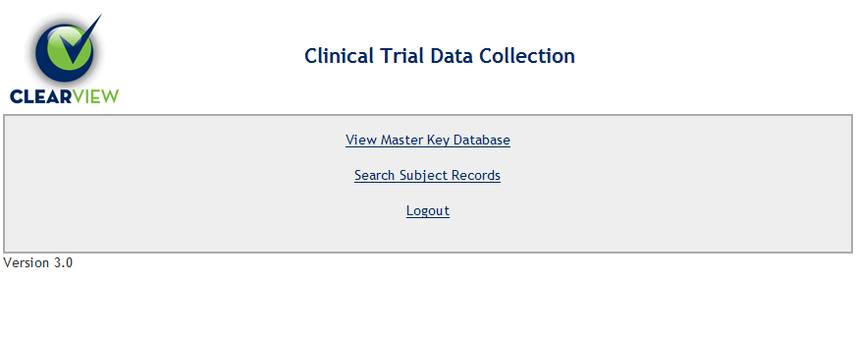
Verified Not Verified Non-Conformance Ref. No.

    - Logout Function. Click on the Logout link. Verify that the Log In screen reappears.

Verified Not Verified Non-Conformance Ref. No.

    - View Master Key Database

Log in as “ra1”. Click the View Master Key Database. Verify that the screen displays a list of Subject IDs, Subject Names, Birthdates, Location, and Date Created.

Verified Not Verified Non-Conformance Ref. No.

Click the Arrows to the right of the ID column. Verify that the list is sorted numerically by ID from lowest to highest ID.

Verified Not Verified Non-Conformance Ref. No.

Record the first five record’s information below (NOTE: Subject Name is being omitted on purpose to omit the recording of subject name on any validation record.)

Table 1
No. | ID | Birthdate | Date Created
1
2
3
4
5

Click the Arrows to the right of the ID column. Verify that the list is sorted numerically by ID from Highest to lowest ID.

Verified Not Verified Non-Conformance Ref. No.

Record the first five record’s information below (NOTE: Subject Name is being omitted on purpose to omit the recording of subject name on any validation record.)

Table 2
No. | ID | Birthdate | Date Created
1
2
3
4
5

Verify that the first five displayed records have changed from Table 1 to Table 2.

Verified Not Verified Non-Conformance Ref. No.

Click the Arrows to the right of the Subject Name column. Verify that the list is sorted alphabetically by Subject Name from A to Z.

Verified Not Verified Non-Conformance Ref. No.

Record the first five record’s information below (NOTE: Subject Name is being omitted on purpose to omit the recording of subject name on any validation record.)

Table 3
No. | ID | Birthdate | Date Created
1
2
3
4
5

Click the Arrows to the right of the Subject Name column. Verify that the list is sorted alphabetically by Subject Name from Z to A.

Verified Not Verified Non-Conformance Ref. No.

Record the first five record’s information below (NOTE: Subject Name is being omitted on purpose to omit the recording of subject name on any validation record.)

Table 4
No. | ID | Birthdate | Date Created
1
2
3
4
5

Verify that the first five displayed records have changed from Table 3 to Table 4.

Verified Not Verified Non-Conformance Ref. No.

Click the Arrows to the right of the Birthdate column. Verify that the list is sorted chronically by Birthdate from oldest to youngest.

Verified Not Verified Non-Conformance Ref. No.

Record the first five record’s information below (NOTE: Subject Name is being omitted on purpose to omit the recording of subject name on any validation record.)

Table 5
No. | ID | Birthdate | Date Created
1
2
3
4
5

Click the Arrows to the right of the Birthdate column. Verify that the list is sorted chronically by Birthdate from youngest to oldest.

Verified Not Verified Non-Conformance Ref. No.

Record the first five record’s information below (NOTE: Subject Name is being omitted on purpose to omit the recording of subject name on any validation record.)

Table 6
No. | ID | Birthdate | Date Created
1
2
3
4
5

Verify that the first five displayed records have changed from Table 5 to Table 6.

Verified Not Verified Non-Conformance Ref. No.

Click the Arrows to the right of the Location column. Verify that the list is sorted alphabetically by Location from A to Z.

Verified Not Verified Non-Conformance Ref. No.

Record the first five record’s information below (NOTE: Subject Name is being omitted on purpose to omit the recording of subject name on any validation record.)

Table 7
No. | ID | Birthdate | Date Created
1
2
3
4
5

Click the Arrows to the right of the Location column. Verify that the list is sorted reverse alphabetically by Location from Z to A.

Verified Not Verified Non-Conformance Ref. No.

Record the first five record’s information below (NOTE: Subject Name is being omitted on purpose to omit the recording of subject name on any validation record.)

Table 8
No. | ID | Birthdate | Date Created
1
2
3
4
5

Verify that the first five displayed records have changed from Table 7 to Table 8.

Verified Not Verified Non-Conformance Ref. No.

Click the Arrows to the right of the Date Created column. Verify that the list is sorted chronically by Date Created from oldest to newest.

Verified Not Verified Non-Conformance Ref. No.

Record the first five record’s information below (NOTE: Subject Name is being omitted on purpose to omit the recording of subject name on any validation record.)

Table 9
No. | ID | Birthdate | Date Created
1
2
3
4
5

Click the Arrows to the right of the Date Created column. Verify that the list is sorted chronically by Date Created from newest to oldest ID.

Verified Not Verified Non-Conformance Ref. No.

Record the first five record’s information below (NOTE: Subject Name is being omitted on purpose to omit the recording of subject name on any validation record.)

Table 10
No. | ID | Birthdate | Date Created
1
2
3
4
5

Verify that the first five displayed records have changed from Table 9 to Table 10.

Verified Not Verified Non-Conformance Ref. No.

Click on the Main Menu link at the bottom of the page. Verify that the screen containing View Master Key Database, Search Subject Records and Logout links appears.

Verified Not Verified Non-Conformance Ref. No.

    - Search Subject Records function. This link allows the Research Assistant to view subjects, change and/or add data, add notes, and mark and un-mark check boxes when subjects are scanned or if subjects did not participate.

Click on the Search Subject Records link. Verify that a new screen appears with a table of records including columns for ID, Initials, Birthdate and more.

Verified Not Verified Non-Conformance Ref. No.

Locate the record with Initials JJJ and Birthdate of 06/05/1950. Click in the Subject Id box and type in "EPIC-" then the first three numbers of JJJ's Subject Id. Click the Search button. Verify that only JJJ’s ID appears in the subject list.

Verified Not Verified Non-Conformance Ref. No.

Click in the Subject Id box, delete the previous entry, and type in “1234567.” Click the Search button. Verify that the subject list says “There are no records available.”

Verified Not Verified Non-Conformance Ref. No.

Click on the Main Menu link. Verify that the screen containing View Master Key Database, Search Subject Records and Logout links appears.

Verified Not Verified Non-Conformance Ref. No.

Click on the Search Subject Records link. Click on the line containing the Initials JAN and Birthdate of 4/18/1940. Verify that the Demographic screen opens for subject JAN.
Verified Not Verified Non-Conformance Ref. No.

Highlight and click to open the Recruitment/Scanning page. Check the Did Not Participate box. Click on the Main Menu link. Click on Search Subject Records link. Click on the line containing JAN. Click on the Recruitment/Scanning page. Verify that the Did Not Participate box remains unchecked.

Verified Not Verified Non-Conformance Ref. No.

Check the Did Not Participate box. Enter 5/1/2011 in the date field. Click on the Save button. Verify that JAN’s ID and subject information is still displayed on the screen.

Verified Not Verified Non-Conformance Ref. No.

Click on the Save & Close button. Verify that the screen returns to the list of subject IDs.

Verified Not Verified Non-Conformance Ref. No.

Below the Subject Id box, next to Participated?, click the Yes button. Click the Search button. Attempt to locate JAN’s ID by entering the subject ID (including the EPIC-) into the search box and clicking the Search button. Verify that the subject ID is not listed in the list.

Verified Not Verified Non-Conformance Ref. No.

Next to Participated, click the No button. Click the Search button. Locate JAN’s ID. Verify that JAN’s ID is listed in the list.

Verified Not Verified Non-Conformance Ref. No.

Next to Participated, click the Either button. Click the Search button. Verify that the list is populated with many more records. Locate JAN’s ID. Verify that JAN’s ID is listed in the list.

Verified Not Verified Non-Conformance Ref. No.

Locate the record with Initials JJJ and Birthdate of 6/5/1950. Click on that line and verify that the Demographics page opens for subject JJJ. Highlight and click to open the Recruitment/Scanning page. Record below the status of the Did Not Participate check box:

Is the Did Not Participate box checked? Yes _____ No _____

Highlight and click to open the Summary/Completion page. Scroll to the bottom of the page. Record the status of the Monitoring Complete check box.

Is the Monitoring Complete box checked? Yes _____ No _____

Click on the Search link. Verify that the screen returns to the list of records. Locate the record with Initials JJJ and Birthdate of 6/5/1950. Record the status of the column headed Didn’t Participate.

Didn’t Participate? Yes _____ No _____

Record the status of the column headed Data.

Data Yes _____ No _____

Verify that the above results are the same for Did Not Participate vs. Didn’t Participate, and Monitoring Complete vs. Data.

Verified Not Verified Non-Conformance Ref. No.

Locate the record with Initials RMR and Birthdate of 10/27/1972. Click on that line and verify that the Demographics page opens for subject RMR. Highlight and click to open the Recruitment/Scanning page. Record below the status of the Did Not Participate check box:

Is the Did Not Participate box checked? Yes _____ No _____

Highlight and click to open the Summary/Completion page. Scroll to the bottom of the page. Record the status of the Monitoring Complete check box.

Is the Monitoring Complete box checked? Yes _____ No _____

Click on the Search link. Verify that the screen returns to the list of records. Locate the record with Initials RMR and Birthdate of 10/27/1972. Record the status of the column headed Didn’t Participate.

Didn’t Participate? Yes _____ No _____

Record the status of the column headed Data.

Data Yes _____ No _____

Verify that the above results are the same for Did Not Participate vs. Didn’t Participate, and Monitoring Complete vs. Data.

Verified Not Verified Non-Conformance Ref. No.

Locate the record with initials TJJ and Birthdate of 8/12/1971. Click on that line and verify that the Demographics Page opens. Delete the entries for the first, middle and last name, replace with the name Arthur Abel Adams. Click the Save & Close button. Verify that the screen returns to the list of records. Verify that a record now exists with initials AAA and Birthdate of 8/12/1971.

Verified Not Verified Non-Conformance Ref. No.

Click on the line with initials AAA and Birthdate of 8/12/1971.
Verify that the Subject Name fields display “A” for First, Middle and Last.

Verified Not Verified Non-Conformance Ref. No.

Click the arrow in the ID column header. Verify that the subject list is resorted by ID number in ascending order. Click on the record with ID EPIC-0016232. Verify that the Demographics page opens for Subject ID EPIC-0016232. Verify that data is present in only the Names, Date of Birth, Gender, and Location text box.

Verified Not Verified Non-Conformance Ref. No.

Highlight and click the Summary/Completion page. Verify that the “continue?” dialog box opens. Click OK and verify that the Summary/Completion page opens. Scroll down the page and verify that data (including filled buttons and checked boxes) is present in only the Names, Date of Birth, Gender, and Location text box.

Verified Not Verified Non-Conformance Ref. No.

Highlight and click the Legacy page. Verify that the “continue?” dialog box opens. Click OK and verify that the Legacy page opens. Verify that the record for EPIC-0016232 appears as:

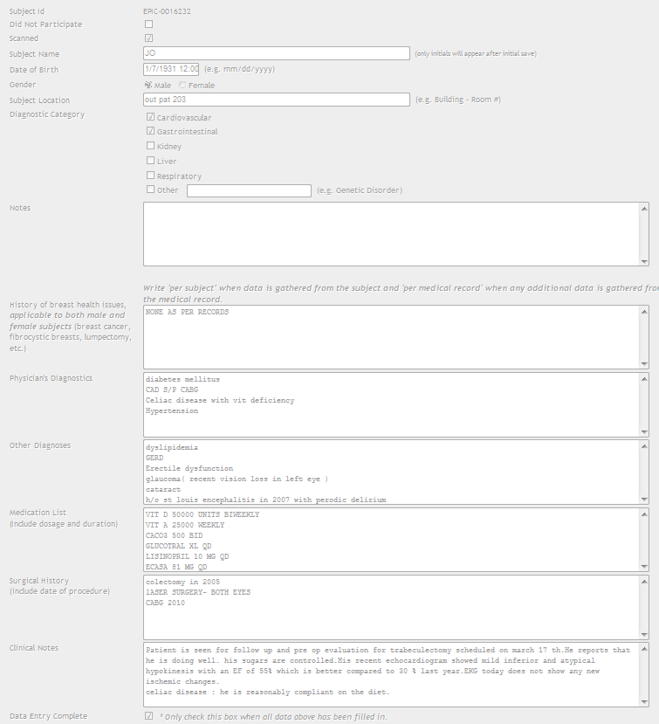

Verified Not Verified Non-Conformance Ref. No.

Click on the Main Menu link at the bottom of the page. Verify that the screen containing View Master Key Database, Search Subject Records and Logout links appears. Click on the Logout link and verify the Please Log In screen appears.

Verified Not Verified Non-Conformance Ref. No.

  - Clinical Coordinator Functions

    - Please Log In function. This window provides the user a method to enter their user name and password in order to access the web form application.

Click in the User Name box and enter “cc1”. Click in the password box and enter “cc1”. Click the Log In button. Verify that a red message appears saying “Invalid Login,” the User Name box contains “cc1”, and the Password box is empty.

Verified Not Verified Non-Conformance Ref. No.

Click in the User Name box and enter “cc1.” Click in the password box and enter “password.” Click the Log In button. Verify that the Main Menu with the View Master Key Database, Search Subject Records, Add Subject, Report and Logout links appears as below:
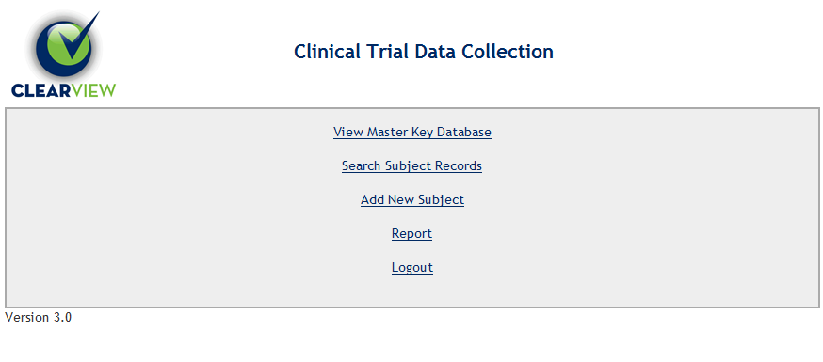
Verified Not Verified Non-Conformance Ref. No.

    - Logout Function. Click on the Logout link. Verify that the Log In screen reappears.

Verified Not Verified Non-Conformance Ref. No.

Login as the Clinical Coordinator using the information from Section 6.2.1.

    - View Master Key Database

Click the View Master Key Database. Verify that the screen displays a list of Subject IDs, Subject Names, Birthdates, and Date Created.

Verified Not Verified Non-Conformance Ref. No.

Click the Main Menu link at the bottom of the page. Verify that the Main Menu with the View Master Key Database, Search Subject Records, Add Subject, Report and Logout links appears.

Verified Not Verified Non-Conformance Ref. No.

    - Search Subject Records function. This link allows the Clinical Coordinator to view subjects, change basic and clinical data, add notes, and mark and un-mark check boxes when subjects are scanned, if subjects did not participate, and when data entry is complete.

Click on the Search Subject Records link. Verify that a new screen appears with a table of records including columns for ID, Initials, Birthdate and more.

Verified Not Verified Non-Conformance Ref. No.

Click the Main Menu link at the bottom of the page. Verify that the Main Menu with the View Master Key Database, Search Subject Records, Add Subject, Report and Logout links appears.

Verified Not Verified Non-Conformance Ref. No.

    - Add New Subject function. This link allows the Clinical Coordinator to add new trial subjects.

Demographics page

Click on the Add New Subject Link. Verify that the Demographics page appears. Verify that a menu of pages appears on the left side of the screen with Demographics at the top and highlighted.

Verified Not Verified Non-Conformance Ref. No.

Verify that the top line, Subject ID, displays a letter and number combination and record the result:

Subject ID: _________________________________

Click the Main Menu link at the bottom of the screen. Verify that the screen returns to the Main Menu.

Verified Not Verified Non-Conformance Ref. No.

Click on the Add New Subject link. Verify that the Demographics page opens. Verify that the top line, Subject ID, displays a letter and number combination and record the result:

Subject ID: _________________________________

Verify that the Subject ID is different the ID in the previous step.

Verified Not Verified Non-Conformance Ref. No.

Highlight and click the Family History page on the left side of the screen. Verify that the highlight returns to Demographics and the “continue?” dialog box opens.

Verified Not Verified Non-Conformance Ref. No.

Click OK in the “continue?” dialog box. Verify that the dialog box closes and the Family History page opens and Family History is highlighted.

Verified Not Verified Non-Conformance Ref. No.

Highlight and click the Demographics page. Verify that the “continue?” dialog box opens. Click OK. Verify that the dialog box closes and the Demographics page opens.

Verified Not Verified Non-Conformance Ref. No.

Highlight and click the Adverse Effects page. Verify that the “continue?” dialog box opens. Click Cancel. Verify that the dialog box closes and the Demographics page appears as shown below with the error messages in red:

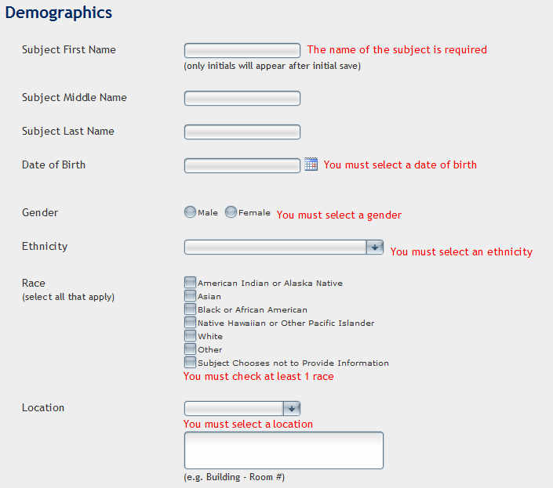

Verified Not Verified Non-Conformance Ref. No.

In the Subject First Name box, type “Pat”. In the Subject Middle Name box, type “Lee”. In the Subject Last Name box, type “Patterson”. Click the Save button at the bottom of the form. Verify that the “name required” error message disappears.

Verified Not Verified Non-Conformance Ref. No.

Click in the Date of Birth box. Type in the Date of Birth as “a/5/1950.” Click the Save button at the bottom of the form. Verify that a “valid date form” red error message appears next to the Date of Birth field.

Verified Not Verified Non-Conformance Ref. No.

Click in the Date of Birth box. Type in the Date of Birth as “5/5/50.” Click the Save button. Verify that a “valid date form” red error message appears next to the Date of Birth field.

Verified Not Verified Non-Conformance Ref. No.

Click in the Date of Birth box. Type in the birth date as “5/5/1950.” Click the Save button. Verify that there is no Date of Birth error.

Verified Not Verified Non-Conformance Ref. No.

Click the Female button in the Gender line. Click the Save button. Verify that the “must select” error disappears and the Female button remains filled.

Verified Not Verified Non-Conformance Ref. No.

Click the Male button in the Gender line. Click the Save button. Verify that there is no Gender error and the Male button remains filled.

Verified Not Verified Non-Conformance Ref. No.

Click the arrow in the Ethnicity field to display options. Select the “Hispanic or Latino” option. Click the Save button. Verify that the “must select” error disappears and “Hispanic or Latino” is displayed in the Ethnicity field.

Verified Not Verified Non-Conformance Ref. No.

Click the arrow in the Ethnicity field to display options. Select the “Not Hispanic or Latino” option. Click the Save button. Verify that there is no Ethnicity error and “Not Hispanic or Latino” is displayed in the Ethnicity field.

Verified Not Verified Non-Conformance Ref. No.

Click the arrow in the Ethnicity field to display options. Select the “Subject chooses not to disclose” option. Click the Save button. Verify that there is no Ethnicity error and “Subject chooses not to disclose” is displayed in the Ethnicity field.

Verified Not Verified Non-Conformance Ref. No.

Click to check the “American Indian or Alaska Native” Race box. Click the Save button. Verify that the “American Indian or Alaska Native” box remains checked and the “must check” error disappears.

Verified Not Verified Non-Conformance Ref. No.

Click to uncheck the “American Indian or Alaska Native” Race box. Click the Save button. Verify that the “American Indian or Alaska Native” box remains unchecked and the “must check” error appears.

Verified Not Verified Non-Conformance Ref. No.

Click to check the “Asian” Race box and the “White” Race box. Click the Save button. Verify that the “Asian” and “White” boxes remain checked there is no Race error.

Verified Not Verified Non-Conformance Ref. No.

Click to check the “American Indian”, “Black”, and the “Native Hawaiian” Race boxes. Click the Save button. Verify that the first five Race boxes remain checked.

Verified Not Verified Non-Conformance Ref. No.

Click to check the “Other” Race box. Verify that a text field opens below the “Other” box. Type in “Spanish”. Click the Save button. Verify that all Race option boxes remain checked and “Spanish” remains in the Other text field.

Verified Not Verified Non-Conformance Ref. No.

Click to check the “Subject Chooses not to Provide Information” Race box. Verify that all other Race boxes uncheck and the Other text field closes. Click the Save button. Verify that the “Subject Chooses not to Provide Information” Race box is the only one checked.

Verified Not Verified Non-Conformance Ref. No.

Attempt to check any Race box. Verify that all are locked out. Click to uncheck the “Subject Chooses not to Provide Information” Race box. Click to check the “White” Race box. Click the Save button. Verify that the “White” Race box remains checked.

Verified Not Verified Non-Conformance Ref. No.

Click the arrow in the location field to display options. Select the N/A option. Click the Save button. Verify that “N/A” is displayed in the Location field and the “must select” error disappears.

Verified Not Verified Non-Conformance Ref. No.

Verify that a green “success” message appears near the top of the page and that the Subject Initials, Gender, and Date of Birth data is displayed at the top of the page under Subject ID.

Verified Not Verified Non-Conformance Ref. No.

Click the arrow in the location field to display options. Select the Inpatient option. In the text box below, type “Building 5, Room 200”. Click the Save Button. Verify that “Inpatient” is displayed in the Location field and “Building 5, Room 200” is displayed in the text box.

Verified Not Verified Non-Conformance Ref. No.

Click the arrow in the location field to display options. Select the Outpatient option. In the text box below, delete all text. Click the Save button. Verify that “Outpatient” is displayed in the Location field and the text box is empty.

Verified Not Verified Non-Conformance Ref. No.

Recruitment/Scanning page

Highlight and click the Recruitment/Scanning page. Verify that the Recruitment/Scanning page opens.

Verified Not Verified Non-Conformance Ref. No.

Click to check the “Consent form signed” box. Verify that a date field and calendar open next to the box. Click to uncheck the “Consent form signed” box. Verify that the date field and calendar disappear.

Verified Not Verified Non-Conformance Ref. No.

Click to check the “Consent form signed” box. Verify that a date field and calendar open next to the box. Click to open the calendar. Attempt to select tomorrow’s date. Verify that all future dates are not selectable. Click outside the calendar to close calendar. Type tomorrow’s date into the date field. Click the save button. Verify that a “must select” red error message appears.

Verified Not Verified Non-Conformance Ref. No.

Type “4/1/2011” into date field. Click the Save button. Verify that “4/1/2011” remains in the date field, the “must select” error message disappears, and a green “success” message appears near the top of the page.

Verified Not Verified Non-Conformance Ref. No.

Delete the date in the date field. Click the Save button. Verify that a “must select” red error message appears and the green “success” message disappears.

Verified Not Verified Non-Conformance Ref. No.

Click to open the calendar. Select today’s date. Verify that today’s date is shown in the date field and the calendar closes. Click the Save button. Verify that today’s date remains in the date field, the “must select” error message disappears, and a green “success” message appears near the top of the page.

Verified Not Verified Non-Conformance Ref. No.

Click to check the “Scanned” box. Verify that a date field and calendar open next to the box. Click to uncheck the “Scanned” box. Verify that the date field and calendar disappear.

Verified Not Verified Non-Conformance Ref. No.

Click to check the “Scanned” box. Verify that a date field and calendar open next to the box. Click to open the calendar. Attempt to select tomorrow’s date. Verify that all future dates are not selectable. Click outside the calendar to close calendar. Type tomorrow’s date into the date field. Click the save button. Verify that a “must select” red error message appears and the green “success” message disappears.

Verified Not Verified Non-Conformance Ref. No.

Type “4/1/2011” into date field. Click the Save button. Verify that “4/1/2011” remains in the date field, the “must select” error message disappears, and a green “success” message appears near the top of the page.

Verified Not Verified Non-Conformance Ref. No.

Delete the date in the date field. Click the Save button. Verify that a “must select” red error message appears.

Verified Not Verified Non-Conformance Ref. No.

Click to open the calendar. Select today’s date. Verify that today’s date is shown in the date field and the calendar closes. Click the Save button. Verify that today’s date remains in the date field, the “must select” error message disappears, and a green “success” message appears near the top of the page.

Verified Not Verified Non-Conformance Ref. No.

Click to check the “Did Not Participate” box. Verify that a date field and calendar open next to the box, and six check boxes below. Click to uncheck the “Did Not Participate” box. Verify that the date field, calendar and check boxes disappear.

Verified Not Verified Non-Conformance Ref. No.

Click to check the “Did Not Participate” box. Verify that a date field and calendar open next to the box, and six check boxes below. Click to open the calendar. Attempt to select tomorrow’s date. Verify that all future dates are not selectable. Click outside the calendar to close calendar. Type tomorrow’s date into the date field. Click the save button. Verify that a “must select” red error message appears.

Verified Not Verified Non-Conformance Ref. No.

Type “4/1/2011” into date field. Click the Save button. Verify that “4/1/2011” remains in the date field, the “must select” error message disappears, and a green “success” message appears near the top of the page.

Verified Not Verified Non-Conformance Ref. No.

Delete the date in the date field. Click the Save button. Verify that a “must select” red error message appears.

Verified Not Verified Non-Conformance Ref. No.

Click to open the calendar. Select today’s date. Verify that today’s date is shown in the date field and the calendar closes. Click the Save button. Verify that today’s date remains in the date field, the “must select” error message disappears, and a green “success” message appears near the top of the page.

Verified Not Verified Non-Conformance Ref. No.

Click to check the first five boxes below Did Not Participate. Click the Save button. Verify that the five boxes remain checked.

Verified Not Verified Non-Conformance Ref. No.

Click to uncheck the first five boxes below Did Not Participate. Click to check the Other box. Verify that a text field opens below the Other box. Click the Save button. Verify that a “must fill in” red error message appears.

Verified Not Verified Non-Conformance Ref. No.

In the Other text field type in “Subject no longer available”. Click the Save button. Verify that the Other box remains checked and “Subject no longer available” appears in the Other text field.

Verified Not Verified Non-Conformance Ref. No.

In the Notes text field type in “Subject was discharged”. Click the Save button. Verify that “Subject was discharged” appears in the Notes text field.

Verified Not Verified Non-Conformance Ref. No.

Click to uncheck the “Did Not Participate” box. Verify that the date field, calendar and check boxes disappear. Click the Save button. Verify that the “Did Not Participate” box remains unchecked and a green “success” message appears near the top of the page.

Verified Not Verified Non-Conformance Ref. No.

Inclusion/Exclusion page
Highlight and click the Inclusion/Exclusion page. Verify that the Inclusion/Exclusion page opens.

Verified Not Verified Non-Conformance Ref. No.

Highlight and click the Pre-qualifiers/Baseline page. Verify that the screen stays on the Inclusion/Exclusion page and a “continue?” dialog box opens, and a “select yes or no” and a “fill out exit form” red error messages appear near the top of the page. Click Cancel. Verify that the dialog box closes and the error messages remain. Click the Save button. Verify that the error messages remain.

Verified Not Verified Non-Conformance Ref. No.

Click the Yes button for every question. Click the Save button. Verify that a “fill out exit form” dialog box opens. Click OK and verify that the dialog box closes, all Yes buttons are filled, the red error messages disappear, and a green “success” message appears near the top of the form.

Verified Not Verified Non-Conformance Ref. No.

Click the Save button. Verify that a “fill out exit form” dialog box opens. Click Cancel and verify that the dialog box closes, all Yes buttons are filled, and a “fill out exit form” red error message appears.

Verified Not Verified Non-Conformance Ref. No.

Click the No button for every question. Click the Save button. Verify that all No buttons are filled and a green “success” message appears near the top of the form.

Verified Not Verified Non-Conformance Ref. No.

Pre-qualifiers/Baseline page
Highlight and click the Pre-qualifiers/Baseline page. Verify that the Pre-qualifiers/Baseline page opens.

Verified Not Verified Non-Conformance Ref. No.

Highlight and click the Adverse Events page. Verify that the screen stays on the Pre-qualifiers/Baseline page and a “continue?” dialog box opens, and a “select yes or no” red error message appears. Click Cancel. Verify that the dialog box closes and the error messages remain. Click the Save button. Verify that the error messages remain.

Verified Not Verified Non-Conformance Ref. No.

Click the Yes button for every question. Verify that a text field opens to the right of each Yes button. Click the Save button. Verify that the Yes buttons are filled and a “enter a description” red error message appears next to each text field.

Verified Not Verified Non-Conformance Ref. No.

Next to the “Caffeine …” question, type in “Coffee 1-1/2 hours prior” in the text field. Click the Save button. Verify that “Coffee 1-1/2 hours prior” appears and the error message disappears for the Caffeine text field.

Verified Not Verified Non-Conformance Ref. No.

Click the No button for every question except the Caffeine question. Verify that the text fields close for each question. Click the Save button. Verify that all No buttons are filled except the Caffeine question, and the “select yes or no” error message disappears.

Verified Not Verified Non-Conformance Ref. No.

Adverse Events page
Highlight and click the Adverse Events page. Verify that the Adverse Events page opens.

Verified Not Verified Non-Conformance Ref. No.

Highlight and click the Symptomatology page. Verify that the screen stays on the Adverse Events page and a “continue?” dialog box opens, and a “select Yes or No” red error message appears. Click Cancel. Verify that the dialog box closes and the error message remains. Click the Save button. Verify that the error message remains.

Verified Not Verified Non-Conformance Ref. No.

Click the No button. Click the Save button. Verify that the No button is filled, the “select Yes or No” error message disappears, and a green “success” message appears.

Verified Not Verified Non-Conformance Ref. No.

Click the Yes button. Verify that a text field opens. In the Explain text field, type in “Slight shock”. Click the Save button. Verify that the No button is empty, the Yes button is filled, “Slight shock” appears in the Explain text field, and a green “success” message appears.

Verified Not Verified Non-Conformance Ref. No.

Symptomatology page

Highlight and click the Symptomatology page. Verify that the Symptomatology page opens.

Verified Not Verified Non-Conformance Ref. No.

Highlight and click the Lifestyle/Behavioral page. Verify that the screen stays on the Symptomatology page and a “continue?” dialog box opens, and a “fill out every field” red error message appears. Click Cancel. Verify that the dialog box closes and the error message remains. Click the Save button. Verify that the error message remains.

Verified Not Verified Non-Conformance Ref. No.

Next to the “medical problems” and “allergic” questions, click the Yes button. Verify that a text field opens to the right of the Yes button for each and a “enter a description” red error message appears. Type “Sample” in each text field. Click the Save button. Verify that the Yes button is filled and “Sample” appears in each text box, and the “enter a description” error messages disappear.

Verified Not Verified Non-Conformance Ref. No.

Next to the “vision problems” question, click the Yes button. Verify that two question boxes open below and the “select” red error messages appear.

Verified Not Verified Non-Conformance Ref. No.

Next to the “corrected” question, click the No button. Verify the No button only is filled. Click the Unknown button. Verify the Unknown button only is filled. Click the Yes button. Verify the Yes button is filled. Click the Save button. Verify that the Yes button only is filled and the “select” error message disappears.

Verified Not Verified Non-Conformance Ref. No.

Next to the “worse uncorrected” question, click the Left button. Verify that the Left button only is filled. Click the Right button. Verify that the Right button only is filled. Click the Unknown button. Verify the Unknown button only is filled. Click the Neither button. Click the Save button. Verify that the Neither button only is filled and the “select” error message disappears.

Verified Not Verified Non-Conformance Ref. No.

Next to the “other eye problems” question, click the Yes button. Verify that four check boxes open below and the “Which eye is affected?” question box opens. Verify that the “check one” and “choose one” red error messages appear.

Verified Not Verified Non-Conformance Ref. No.

Next to the “other eye problems” question, click to check each box and type in “Sample” in the Other text field. Click the Save button. Verify that the Yes button is filled, all four boxes are checked, “Sample” appears in the Other text field, and the “check one” error message disappears.

Verified Not Verified Non-Conformance Ref. No.

Next to the “Which eye is affected?” question, click the Left button. Verify that the Left button only is filled. Click the Right button. Verify that the Right button only is filled. Click the Unknown button. Verify that the Unknown button only is filled. Click the Both button. Verify that the “which eye is worse?” question box opens below with the “choose one” red error message. Click the Save button. Verify that the Both button is filled and the first “choose one” error message disappears.

Verified Not Verified Non-Conformance Ref. No.

Next to the “which eye is worse?” question, click the Left button. Verify that the Left button only is filled. Click the Right button. Verify that the Right button only is filled. Click the Unknown button. Verify that the Unknown button only is filled. Click the Same button. Click the Save button. Verify that the Same button only is filled and the “choose one” error message disappears.

Verified Not Verified Non-Conformance Ref. No.

Next to the “problems with your ears?” question, click the Yes button. Verify that the Yes button is filled and the “Which ear?” question box opens below with the “choose one” red error message.

Verified Not Verified Non-Conformance Ref. No.

Next to the “Which ear?” question, click the Left button. Verify that the Left button only is filled. Click the Right button. Verify that the Right button only is filled. Click the Unknown button. Verify that the Unknown button only is filled. Click the Both button. Click the Save button. Verify that the Both button is filled and the “choose one” error message disappears.

Verified Not Verified Non-Conformance Ref. No.

Next to the “hearing aids?” question, click the Yes button. Verify that the Yes button is filled and the “Which ear has hearing aids?” question box opens below with the “choose one” red error message.

Verified Not Verified Non-Conformance Ref. No.

Next to the “Which ear has hearing aids?” question, click the Left button. Verify that the Left button only is filled. Click the Right button. Verify that the Right button only is filled. Click the Unknown button. Verify that the Unknown button only is filled. Click the Both button. Click the Save button. Verify that the Both button is filled and the “choose one” error message disappears.

Verified Not Verified Non-Conformance Ref. No.

Next to the “problems with sinuses” question, click the Yes button. Verify that the Yes button is filled and the “currently active” question opens below with the “choose one” red error message.

Verified Not Verified Non-Conformance Ref. No.

Next to the “currently active” question, click the No button. Verify the No button only is filled. Click the Unknown button. Verify that the Unknown button only is filled. Click the Yes button. Click the Save button. Verify that the Yes button only is filled and the “choose one” error message disappears.

Verified Not Verified Non-Conformance Ref. No.

Next to the “seasonal allergies” question, click the Yes button. Verify that the Yes button is filled and the “currently suffering” question opens below with the “choose one” red error message.

Verified Not Verified Non-Conformance Ref. No.

Next to the “currently suffering” question, click the No button. Verify the No button only is filled. Click the Unknown button. Verify that the Unknown button only is filled. Click the Yes button. Click the Save button. Verify that the Yes button only is filled and the “choose one” error message disappears.

Verified Not Verified Non-Conformance Ref. No.

Next to the “problems with teeth” question, click the Yes button. Verify that the Yes button is filled and the “Which side of mouth” question opens below with six check boxes – Right upper, Left upper, Right lower, Left lower, Front upper, Front lower, and the “check one” red error message appears.

Verified Not Verified Non-Conformance Ref. No.

Next to the “Which side of mouth” question, click to check all six boxes. Click the Save button. Verify that all six boxes are checked and the “check one” error message disappears.

Verified Not Verified Non-Conformance Ref. No.

Next to the “history of spinal injury” question, click the Yes button. Verify that the Yes button is filled and the “Which part of the spine” question opens below with the “check one” red error message.

Verified Not Verified Non-Conformance Ref. No.

Next to the “Which part of the spine” question, click to check the Upper, Middle and Lower boxes. Click the Save button. Verify that the Upper, Middle and Lower boxes are checked and the “check one” error message disappears.

Verified Not Verified Non-Conformance Ref. No.

Next to the “Which part of the spine” question, click to check the Unknown box. Verify that the Upper, Middle and Lower checkboxes become blank and inactive. Click the Save button. Verify that the Unknown box remains checked.

Verified Not Verified Non-Conformance Ref. No.

Next to the “frequent back pain” question, click the Yes button. Verify that the Yes button is filled and the “Which part of the spine” question opens below with the “check one” red error message.

Verified Not Verified Non-Conformance Ref. No.

Next to the “Which part of the spine” question, click to check the Upper, Middle and Lower boxes. Click the Save button. Verify that the Upper, Middle and Lower boxes are checked and the “check one” error message disappears.

Verified Not Verified Non-Conformance Ref. No.

Next to the “Which part of the spine” question, click to check the Unknown box. Verify that the Upper, Middle and Lower checkboxes become blank and inactive. Click the Save button. Verify that the Unknown box remains checked.

Verified Not Verified Non-Conformance Ref. No.
Next to the “shoulder pain” question, click the Yes button. Verify that the Yes button is filled and the “Which shoulder” question box opens below with the “choose one” red error message.

Verified Not Verified Non-Conformance Ref. No.

Next to the “Which shoulder” question, click the Left button. Verify that the Left button only is filled. Click the Right button. Verify that the Right button only is filled. Click the Unknown button. Verify that the Unknown button only is filled. Click the Both button. Click the Save button. Verify that the Both button only is filled and the “choose one” error message disappears.

Verified Not Verified Non-Conformance Ref. No.

Next to the following ten “currently suffer” and “frequently suffer” questions, click the Yes button of each. Click the Save button. Verify that the ten Yes buttons are filled.

Verified Not Verified Non-Conformance Ref. No.

Next to the “diagnosed with a hernia?” question, click the Yes button. Verify that the Yes button is filled, the “Where was the hernia?” question box opens below with a blank text field with the “enter information” red error message. Verify that the “Has it been repaired?” question box opens below with the “choose one” red error message.

Verified Not Verified Non-Conformance Ref. No.

Next to the “Where was the hernia?” question, type in “Sample” in the text field. Click the Save button. Verify that “Sample” appears in the text field and the “enter information” error message disappears.

Verified Not Verified Non-Conformance Ref. No.
Next to the “Where was the hernia?” question, click the Unknown check box. Click the Save button. Verify that the Unknown box is checked and the text field is inactive.

Verified Not Verified Non-Conformance Ref. No.

Next to the “Has it been repaired?” question, click the No button. Verify the No button only is filled. Click the Unknown button. Verify the Unknown button only is filled. Click the Yes button. Click the Save button. Verify that the Yes button only is filled and the “choose one” error message disappears, the “fill out every field” error message disappears, and a green “success” message appears near the top of the page.

Verified Not Verified Non-Conformance Ref. No.

Next to all of the primary (gray) questions on the Symptomatology page, click the Unknown button. Click the Save button. Verify that all of the Unknown buttons are filled, all of the No and Yes buttons are empty, and all of the secondary question boxes and text fields disappear.

Verified Not Verified Non-Conformance Ref. No.

Next to all of the primary questions on the Symptomatology page, click the No button. Click the Save button. Verify that all of the No buttons are filled, all of the Yes and Unknown buttons are empty, and there are no secondary question boxes or text fields open.

Verified Not Verified Non-Conformance Ref. No.

Highlight and click the Demographics page. Next to Gender, click the Female button. Click the Save button. Verify that the Female button remains filled and a green “success” message appears.

Verified Not Verified Non-Conformance Ref. No.

Highlight and click the Symptomatology page. Verify that all of the questions have the No button only filled except for three new “Women only” questions at the bottom of the page. Click the Save button. Verify that a “fill out every field” red error message appears near the top of the page, and a “must select” red error message appears at the bottom.

Verified Not Verified Non-Conformance Ref. No.

Next to the “breast issues” question, click the Yes button. Verify that the Yes button is filled and a “Describe” text field opens with a “must enter” red error message, and a “Which breast?” question opens below with a “select one” red error message.

Verified Not Verified Non-Conformance Ref. No.

Type “Sample” into the text field. Next to the “Which breast?” question, click the Left button. Verify the Left button only is filled. Click the Right button. Verify the Right button only is filled. Click the Unknown button. Verify the Unknown button is filled. Click the Both button. Click the Save button. Verify that “Sample” remains in the text field and the “must enter” error message disappears. Verify the Both button only is filled and the “select one” error message disappears.

Verified Not Verified Non-Conformance Ref. No.

Next to the “been pregnant?” question, click the Yes button. Verify that the Yes button is filled and the “How many births” question box opens below with a “enter number” red error message. Verify that the “any of the following?” question box opens below with seven check boxes below, an Unknown check box to the right, and a “must check” red error message.

Verified Not Verified Non-Conformance Ref. No.

Next to the “How many births” question, enter “3” into the text field. Click the Save button. Verify that “3” remains in the text field and the “enter number” error message disappears. Click to check the Unknown box. Verify that the text box becomes blank and inactive. Click the Save button.

Verified Not Verified Non-Conformance Ref. No.

Next to the “any of the following?” question, click to check the None box. Click the Save button. Verify that the None box remains checked, the other check boxes become inactive, and the “must check” error message disappears.

Verified Not Verified Non-Conformance Ref. No.

Next to the “any of the following?” question, click to uncheck the None box. Verify that the other check boxes become active. Click to check all of the boxes below the None box. Verify that a text field opens below the Other box when checked. Click the Save button. Verify that all boxes except None and Unknown remain checked, and a “must enter” red error message appears below the Other text field.

Verified Not Verified Non-Conformance Ref. No.

Next to the “any of the following?” question, type “Sample” into the Other text field. Click the Save button. Verify that “Sample” remains in the text field and the “must enter” error message disappears.

Verified Not Verified Non-Conformance Ref. No.

Next to the “any of the following?” question, click to check the Unknown box. Verify that all of the other check boxes become blank and inactive. Click the Save button. Verify that the Unknown box remains checked.
Verified Not Verified Non-Conformance Ref. No.

Next to the “still get your period?” question, click the Yes button.
Verify that three question boxes open below; “regular periods?”, “menopause?”, and “menstruating?”, with a “must select for each” red error message.

Verified Not Verified Non-Conformance Ref. No.

Next to the “regular periods?” question, click the No button. Verify the No button only is filled. Click the Unknown button. Verify the Unknown button only is filled. Click the Yes button. Verify that the Yes button only is filled.

Verified Not Verified Non-Conformance Ref. No.

Next to the “menopause?” question, click the No button. Verify the No button only is filled. Click the Unknown button. Verify the Unknown button only is filled. Click the Yes button. Verify that the Yes button only is filled.

Verified Not Verified Non-Conformance Ref. No.

Next to the “menstruating?” question, click the No button. Verify the No button only is filled. Click the Unknown button. Verify the Unknown button only is filled. Click the Yes button. Click the Save button. Verify that the Yes button only is filled and the “must select from each” error message disappears, the “fill out every field” error message disappears, and a green “success” message appears near the top of the page.

Verified Not Verified Non-Conformance Ref. No.

Lifestyle/Behavioral page

Highlight and click the Lifestyle/Behavioral page. Verify that the Lifestyle/Behavioral page opens.

Verified Not Verified Non-Conformance Ref. No.

Highlight and click the Family History page. Verify that the screen stays on the Lifestyle/Behavioral page and a “continue?” dialog box opens, and a “fill out every field” red error message appears. Click Cancel. Verify that the dialog box closes and the error message remains. Click the Save button. Verify that the error message remains.

Verified Not Verified Non-Conformance Ref. No.

Next to the “current tobacco smoker?” question, click the Yes button. Verify that the Yes button is filled and the “How much do you smoke?” question box opens with a text field, two selection boxes, and a “fill in all fields” red error message.

Verified Not Verified Non-Conformance Ref. No.

In the “How much do you smoke?” text field type in “One pack”. In the next selection box, click the down arrow to view options. Select cigarettes, then cigars, then pipes, verifying that each selection appears in the selection box. In the lower selection box, click the down arrow to view options. Select day, then week, then month, then year, verifying that each selection appears in the selection box. Click to check the “Validated” check box. Click the Save button. Next to the “How much do you smoke?” question, verify that “One pack”, “pipes”, and “year” appears in the boxes, “Validated” is checked, and the “fill in all fields” error message disappears.

Verified Not Verified Non-Conformance Ref. No.

Next to the “How much do you smoke?” question, click to check the Unknown check box. Verify that the letters UNK appear lightly in the gray text field, and two selection boxes empty, change to gray and become inactive.

Verified Not Verified Non-Conformance Ref. No.

Next to the “current tobacco smoker” question, click the No button. Verify that the No button is filled and the “How long ago did you quit?” question box opens with a selection box and a “select one” red error message appears.

Verified Not Verified Non-Conformance Ref. No.

Next to the “How long ago did you quit?” selection box, click the arrow to view option. Click on each option to verify they display in the selection box until “>10 years ago” appears. Click to check the “Validated” check box. Click the Save button. Verify that “>10 years ago” appears in the selection box, “Validated” is checked, and the “select one” error message disappears.

Verified Not Verified Non-Conformance Ref. No.

Next to the “How long ago did you quit?” question, click to check the Unknown check box. Verify that the selection box becomes blank and inactive and the Unknown box is checked.

Verified Not Verified Non-Conformance Ref. No.

Next to the “second hand smoke” question, click the Yes button. Verify that the Yes button is filled and the “at home” question box opens and a “select one” red error message.

Verified Not Verified Non-Conformance Ref. No.

Next to the “second hand smoke at home” question, click the No button. Verify that the No button only is filled. Click the Unknown button. Verify the Unknown button only is filled. Click the Yes button. Click the Save button. Verify that the Yes button only is filled and the “select one” error message disappears.

Verified Not Verified Non-Conformance Ref. No.

Next to the “recreational drugs” question, click the Yes button. Verify that the Yes button is filled and the “Which types?” question box opens with a check box for each of the following; Cannabinoid products, Hallucinogens, Narcotics, Other, and Unknown. Verify that a “select one” red error message appears.

Verified Not Verified Non-Conformance Ref. No.

Next to the “Which types?” question, click to check each of the check boxes; Cannabinoid products, Hallucinogens, Narcotics, and Other. Verify that a text field opens next to Other. Type in “Sample”. Click to check the “Validated” box. Click the Save button. Verify all four boxes are checked, “Sample” appears in the Other text field, “Validated” is checked, and the “select one” error message disappears.

Verified Not Verified Non-Conformance Ref. No.

Next to the “Which types?” question, click to check the Unknown check box. Verify that each of the four check boxes unchecks and becomes inactive, and the Other text field closes. Click the Save button. Verify the Unknown check box remains checked.

Verified Not Verified Non-Conformance Ref. No.

Next to the “How many drinks” question, type “2” into the text field. Click to check the “Validated” box. Click the Save button. Verify that “2” appears in the text field and “Validated” is checked.

Verified Not Verified Non-Conformance Ref. No.

Next to each of the remaining questions on the page, type “3” into the text field. Click the Save button. Verify that the remaining fields display “3” in each text field, the “fill out every field” error message disappears, and a green “success” message appears near the top of the page.

Verified Not Verified Non-Conformance Ref. No.

Next to all of the primary (gray) questions on the Lifestyle/Behavioral page, click the Unknown button or check box. Click the Save button. Verify that all of the Unknown buttons are filled or checked, all of the No and Yes buttons are empty, all of the secondary question boxes and text fields disappear, and the primary question boxes become blank and inactive.

Verified Not Verified Non-Conformance Ref. No.

Next to “second hand smoke?” and “recreational drugs?” questions, click the No button. Click the Save button. Verify that the No buttons are filled and the Yes and Unknown buttons are empty.

Verified Not Verified Non-Conformance Ref. No.

Family History page
Highlight and click the Family History page. Verify that the Family History page opens.

Verified Not Verified Non-Conformance Ref. No.

Highlight and click the Qualifying Diagnoses page. Verify that the screen stays on the Family History page and a “continue?” dialog box opens, and a “fill out every field” red error message appears. Click Cancel. Verify that the dialog box closes and the error message remains. Click the Save button. Verify that the error message remains.

Verified Not Verified Non-Conformance Ref. No.
Next to Diabetes, click the Yes button. Verify that the Yes button is filled and the “Which relative(s)?” question box opens with check boxes for Mother, Father, Grandmother, Grandfather, Sibling, Validated and Unknown, and a “must check” red error message. Verify that a text field opens for Type: with a “must enter” red error message.

Verified Not Verified Non-Conformance Ref. No.

Below the “Which relative(s)?” question, click to check all boxes. Enter “2” into the Type: text field. Click to check the Validated box. Click the Save button. Verify that the five relative check boxes are checked, “2” appears in the text field, the Validated box is checked, and the “must enter” error message disappears.

Verified Not Verified Non-Conformance Ref. No.

Next to the “Which relative?” question, click to check the Unknown box. Click the Save button. Verify that the Unknown box is checked, the five relative boxes become blank and inactive.

Verified Not Verified Non-Conformance Ref. No.

Next to High cholesterol, click the Yes button. Verify that the Yes button is filled and the “Which relative(s)?” question box opens with check boxes for Mother, Father, Grandmother, Grandfather, Sibling, Validated and Unknown, and a “must check” red error message.

Verified Not Verified Non-Conformance Ref. No.

Below the “Which relative(s)?” question, click to check all boxes. Click to check the Validated box. Click the Save button. Verify that the five relative check boxes are checked, the Validated box is checked, and the “must enter” error message disappears.

Verified Not Verified Non-Conformance Ref. No.

Next to the “Which relative?” question, click to check the Unknown box. Click the Save button. Verify that the Unknown box is checked, and the five relative boxes become blank and inactive.

Verified Not Verified Non-Conformance Ref. No.

Next to Hepatitis, click the Yes button. Verify that the Yes button is filled and the “Which relative(s)?” question box opens with check boxes for Mother, Father, Grandmother, Grandfather, Sibling, Validated and Unknown, and a “must check” red error message.

Verified Not Verified Non-Conformance Ref. No.

Below the “Which relative(s)?” question, click to check all boxes. Click to check the Validated box. Click the Save button. Verify that the five relative check boxes are checked, the Validated box is checked, and the “must enter” error message disappears.

Verified Not Verified Non-Conformance Ref. No.

Next to the “Which relative?” question, click to check the Unknown box. Click the Save button. Verify that the Unknown box is checked, and the five relative boxes become blank and inactive.

Verified Not Verified Non-Conformance Ref. No.

Next to Hypertension, click the Yes button. Verify that the Yes button is filled and the “Which relative(s)?” question box opens with check boxes for Mother, Father, Grandmother, Grandfather, Sibling, Validated and Unknown, and a “must check” red error message.

Verified Not Verified Non-Conformance Ref. No.

Below the “Which relative(s)?” question, click to check all boxes. Click to check the Validated box. Click the Save button. Verify that the five relative check boxes are checked, the Validated box is checked, and the “must enter” error message disappears.

Verified Not Verified Non-Conformance Ref. No.

Next to the “Which relative?” question, click to check the Unknown box. Click the Save button. Verify that the Unknown box is checked, and the five relative boxes become blank and inactive.

Verified Not Verified Non-Conformance Ref. No.

Next to Coronary artery disease, click the Yes button. Verify that the Yes button is filled and the “Which relative(s)?” question box opens with check boxes for Mother, Father, Grandmother, Grandfather, Sibling, Validated and Unknown, and a “must check” red error message.

Verified Not Verified Non-Conformance Ref. No.

Below the “Which relative(s)?” question, click to check all boxes. Click to check the Validated box. Click the Save button. Verify that the five relative check boxes are checked, the Validated box is checked, and the “must enter” error message disappears.

Verified Not Verified Non-Conformance Ref. No.

Next to the “Which relative?” question, click to check the Unknown box. Click the Save button. Verify that the Unknown box is checked, and the five relative boxes become blank and inactive.

Verified Not Verified Non-Conformance Ref. No.

Next to Valvular disease, click the Yes button. Verify that the Yes button is filled and the “Which relative(s)?” question box opens with check boxes for Mother, Father, Grandmother, Grandfather, Sibling, Validated and Unknown, and a “must check” red error message.

Verified Not Verified Non-Conformance Ref. No.

Below the “Which relative(s)?” question, click to check all boxes. Click to check the Validated box. Click the Save button. Verify that the five relative check boxes are checked, the Validated box is checked, and the “must enter” error message disappears.

Verified Not Verified Non-Conformance Ref. No.

Next to the “Which relative?” question, click to check the Unknown box. Click the Save button. Verify that the Unknown box is checked, and the five relative boxes become blank and inactive.

Verified Not Verified Non-Conformance Ref. No.

Next to Stroke, click the Yes button. Verify that the Yes button is filled and the “Which relative(s)?” question box opens with check boxes for Mother, Father, Grandmother, Grandfather, Sibling, Validated and Unknown, and a “must check” red error message.

Verified Not Verified Non-Conformance Ref. No.

Below the “Which relative(s)?” question, click to check all boxes. Click to check the Validated box. Click the Save button. Verify that the five relative check boxes are checked, the Validated box is checked, and the “must enter” error message disappears.

Verified Not Verified Non-Conformance Ref. No.

Next to the “Which relative?” question, click to check the Unknown box. Click the Save button. Verify that the Unknown box is checked, and the five relative boxes become blank and inactive.

Verified Not Verified Non-Conformance Ref. No.

Next to Asthma or COPD, click the Yes button. Verify that the Yes button is filled and the “Which relative(s)?” question box opens with check boxes for Mother, Father, Grandmother, Grandfather, Sibling, Validated and Unknown, and a “must check” red error message.

Verified Not Verified Non-Conformance Ref. No.

Below the “Which relative(s)?” question, click to check all boxes. Click to check the Validated box. Click the Save button. Verify that the five relative check boxes are checked, the Validated box is checked, and the “must enter” error message disappears.

Verified Not Verified Non-Conformance Ref. No.

Next to the “Which relative?” question, click to check the Unknown box. Click the Save button. Verify that the Unknown box is checked, and the five relative boxes become blank and inactive.

Verified Not Verified Non-Conformance Ref. No.

Next to Bleeding or clotting disorder, click the Yes button. Verify that the Yes button is filled and the “Which relative(s)?” question box opens with check boxes for Mother, Father, Grandmother, Grandfather, Sibling, Validated and Unknown, and a “must check” red error message.

Verified Not Verified Non-Conformance Ref. No.

Below the “Which relative(s)?” question, click to check all boxes. Click to check the Validated box. Click the Save button. Verify that the five relative check boxes are checked, the Validated box is checked, and the “must enter” error message disappears.

Verified Not Verified Non-Conformance Ref. No.

Next to the “Which relative?” question, click to check the Unknown box. Click the Save button. Verify that the Unknown box is checked, and the five relative boxes become blank and inactive.

Verified Not Verified Non-Conformance Ref. No.

Next to Cancer, click the Yes button. Verify that the Yes button is filled and the “Which relative(s)?” question box opens with check boxes for Mother, Father, Grandmother, Grandfather, Sibling, Validated and Unknown, and a “must check” red error message. Verify that a text field opens for Type: with a “must enter” red error message.

Verified Not Verified Non-Conformance Ref. No.

Below the “Which relative(s)?” question, click to check all boxes. Enter “Lung” into the Type: text field. Click to check the Validated box. Click the Save button. Verify that the five relative check boxes are checked, “Lung” appears in the text field, the Validated box is checked, and the “must enter” error message disappears.

Verified Not Verified Non-Conformance Ref. No.

Next to the “Which relative?” question, click to check the Unknown box. Click the Save button. Verify that the Unknown box is checked, the five relative boxes become blank and inactive.

Verified Not Verified Non-Conformance Ref. No.

Next to Renal disease, click the Yes button. Verify that the Yes button is filled and the “Which relative(s)?” question box opens with check boxes for Mother, Father, Grandmother, Grandfather, Sibling, Validated and Unknown, and a “must check” red error message.

Verified Not Verified Non-Conformance Ref. No.

Below the “Which relative(s)?” question, click to check all boxes. Click to check the Validated box. Click the Save button. Verify that the five relative check boxes are checked, the Validated box is checked, and the “must enter” error message disappears.

Verified Not Verified Non-Conformance Ref. No.

Next to the “Which relative?” question, click to check the Unknown box. Click the Save button. Verify that the Unknown box is checked, and the five relative boxes become blank and inactive.

Verified Not Verified Non-Conformance Ref. No.

Next to Thyroid disease, click the Yes button. Verify that the Yes button is filled and the “Which relative(s)?” question box opens with check boxes for Mother, Father, Grandmother, Grandfather, Sibling, Validated and Unknown, and a “must check” red error message.

Verified Not Verified Non-Conformance Ref. No.

Below the “Which relative(s)?” question, click to check all boxes. Click to check the Validated box. Click the Save button. Verify that the five relative check boxes are checked, the Validated box is checked, and the “must enter” error message disappears.

Verified Not Verified Non-Conformance Ref. No.

Next to the “Which relative?” question, click to check the Unknown box. Click the Save button. Verify that the Unknown box is checked, and the five relative boxes become blank and inactive.

Verified Not Verified Non-Conformance Ref. No.

Next to Alcoholism, click the Yes button. Verify that the Yes button is filled and the “Which relative(s)?” question box opens with check boxes for Mother, Father, Grandmother, Grandfather, Sibling, Validated and Unknown, and a “must check” red error message.

Verified Not Verified Non-Conformance Ref. No.

Below the “Which relative(s)?” question, click to check all boxes. Click to check the Validated box. Click the Save button. Verify that the five relative check boxes are checked, the Validated box is checked, and the “must enter” error message disappears.

Verified Not Verified Non-Conformance Ref. No.

Next to the “Which relative?” question, click to check the Unknown box. Click the Save button. Verify that the Unknown box is checked, and the five relative boxes become blank and inactive.

Verified Not Verified Non-Conformance Ref. No.

Next to Depression/Suicide, click the Yes button. Verify that the Yes button is filled and the “Which relative(s)?” question box opens with check boxes for Mother, Father, Grandmother, Grandfather, Sibling, Validated and Unknown, and a “must check” red error message.

Verified Not Verified Non-Conformance Ref. No.

Below the “Which relative(s)?” question, click to check all boxes. Click to check the Validated box. Click the Save button. Verify that the five relative check boxes are checked, the Validated box is checked, and the “must enter” error message disappears.

Verified Not Verified Non-Conformance Ref. No.

Next to the “Which relative?” question, click to check the Unknown box. Click the Save button. Verify that the Unknown box is checked, and the five relative boxes become blank and inactive.

Verified Not Verified Non-Conformance Ref. No.

Next to Genetic disorder, click the Yes button. Verify that the Yes button is filled and the “Which relative(s)?” question box opens with check boxes for Mother, Father, Grandmother, Grandfather, Sibling, Validated and Unknown, and a “must check” red error message. Verify that a text field opens for Type: with a “must enter” red error message.

Verified Not Verified Non-Conformance Ref. No.

Below the “Which relative(s)?” question, click to check all boxes. Enter “Sample” into the Type: text field. Click to check the Validated box. Click the Save button. Verify that the five relative check boxes are checked, “Sample” appears in the text field, the Validated box is checked, and the “must enter” error message disappears. Verify that the “fill in all fields” error message disappears and a green “success” message appears near the top of the page.

Verified Not Verified Non-Conformance Ref. No.

Next to the “Which relative?” question, click to check the Unknown box. Click the Save button. Verify that the Unknown box is checked, the five relative boxes become blank and inactive.

Verified Not Verified Non-Conformance Ref. No.

Next to all of the primary (gray) questions on the Family History page, click the Unknown button. Click the Save button. Verify that all of the Unknown buttons are filled, all of the No and Yes buttons are empty, and all of the secondary question boxes and text fields disappear.

Verified Not Verified Non-Conformance Ref. No.

Next to all of the primary (gray) questions on the Family History page, click the No button. Click the Save button. Verify that all of the No buttons are filled, all of the Yes and Unknown buttons are empty, and all of the secondary question boxes and text fields remain hidden.

Verified Not Verified Non-Conformance Ref. No.

Qualifying Diagnoses page

Highlight and click the Qualify Diagnoses page. Verify that the Qualify Diagnoses page opens.

Verified Not Verified Non-Conformance Ref. No.

Highlight and click the Other Diagnoses page. Verify that the screen stays on the Qualify Diagnoses page and a “continue?” dialog box opens, and a “answer every field” red error message appears. Click Cancel. Verify that the dialog box closes and the error message remains. Click the Save button. Verify that the error message remains.

Verified Not Verified Non-Conformance Ref. No.

Diagnosis entry verification step:
Next to 0101 Coronary artery disease, click the Yes button. Verify that the Yes button is filled and a Diagnosis date field, Evaluated buttons, and a Validated check box open to the right. Verify that a “must select” red error message appears under the Evaluated buttons. Enter “2/2002” into the date field. Under Evaluated, click the Unknown button. Verify the Unknown button only is filled. Click the Yes button. Verify the Yes button only is filled. Click the No button. Verify the No button only is filled. Click to check the Validated box. Click the Save button. Verify that “2/2002” appears in the date field, the Evaluated No button only is filled, and Validated is checked.

Verified Not Verified Non-Conformance Ref. No.

Repeat the above verification step for each of the diagnoses on the page as listed below:

01 Cardiovascular
0102 Left-sided CHF

Verified Not Verified Non-Conformance Ref. No.

0103 Valvular Heart Disease

Verified Not Verified Non-Conformance Ref. No.

0104 Atrial Fibrillation

Verified Not Verified Non-Conformance Ref. No.

0105 Hypertension

Verified Not Verified Non-Conformance Ref. No.

02 Kidney
0201 Pyelonephritis

Verified Not Verified Non-Conformance Ref. No.

0202 Acute renal failure

Verified Not Verified Non-Conformance Ref. No.

0203 Chronic renal failure

Verified Not Verified Non-Conformance Ref. No.

03 Liver
0301 Viral Hepatitus

Verified Not Verified Non-Conformance Ref. No.

0302 Alcohol hepatitis

Verified Not Verified Non-Conformance Ref. No.

0303 Steatohepatitis

Verified Not Verified Non-Conformance Ref. No.

0304 Cirrhosis

Verified Not Verified Non-Conformance Ref. No.

04 Respiratory
0401 Asthma

Verified Not Verified Non-Conformance Ref. No.

0402 COPD

Verified Not Verified Non-Conformance Ref. No.

0403 Bronchitis

Verified Not Verified Non-Conformance Ref. No.

0404 Emphysema

Verified Not Verified Non-Conformance Ref. No.

0405 Pneumonia

Verified Not Verified Non-Conformance Ref. No.

05 Gastrointestinal/Endocrine
0501 Inflammatory bowel disease

Verified Not Verified Non-Conformance Ref. No.

0502 Crohn’s disease

Verified Not Verified Non-Conformance Ref. No.

0503 Ulcerative colitis

Verified Not Verified Non-Conformance Ref. No.

0504 Diverticulities

Verified Not Verified Non-Conformance Ref. No.

0505 Peptic ulcer disease

Verified Not Verified Non-Conformance Ref. No.
0506 Irritable Bowel Syndrome

Verified Not Verified Non-Conformance Ref. No.

0507 Cholecystitis

Verified Not Verified Non-Conformance Ref. No.

0508 Pancreatitis

Verified Not Verified Non-Conformance Ref. No.

0509 Malabsorption

Verified Not Verified Non-Conformance Ref. No.

0510 Diabetes

Verified Not Verified Non-Conformance Ref. No.

Next to the “None of the Above (Control)” question, click the Yes button. Click the Save button. Verify that the Yes button is filled, and a “one or more above is checked Yes” red error message appears.

Verified Not Verified Non-Conformance Ref. No.

Next to the “None of the Above (Control)” question, click the No button. Click the Save button. Verify that the No button only is filled, the “answer every field” error message disappears, and a green “success” message appears near the top of the page.

Verified Not Verified Non-Conformance Ref. No.

Next to all of the primary (gray) questions on the Qualifying Diagnoses page, click the No button. Click the Save button. Verify that all of the No buttons are filled, all of the Yes buttons are empty, all of the secondary question boxes disappear, and the green “success” button remains.

Verified Not Verified Non-Conformance Ref. No.

Other Diagnoses page

Highlight and click the Other Diagnoses page. Verify that the Other Diagnoses page opens.

Verified Not Verified Non-Conformance Ref. No.

Highlight and click the Medications/Supplements page. Verify that the screen stays on the Other Diagnoses page and a “continue?” dialog box opens, and a “answer every field” red error message appears. Click Cancel. Verify that the dialog box closes and the error message remains. Click the Save button. Verify that the error message remains.

Verified Not Verified Non-Conformance Ref. No.

Diagnosis entry verification step:

Next to 1101 Hyperlipidemia (high cholesterol), click the Yes button. Verify that the Yes button is filled and a Diagnosis date field, Evaluated buttons, and a Validated check box open to the right. Verify that a “must select” red error message appears under the Evaluated buttons. Enter “3/2003” into the date field. Under Evaluated, click the Unknown button. Verify the Unknown button only is filled. Click the Yes button. Verify the Yes button only is filled. Click the No button. Verify the No button only is filled. Click to check the Validated box. Click the Save button. Verify that “3/2003” appears in the date field, the Evaluated No button only is filled, and Validated is checked.

Verified Not Verified Non-Conformance Ref. No.

Repeat the above verification step for each of the diagnoses on the page as listed below:

11 Cardiovascular

1102 Angina

Verified Not Verified Non-Conformance Ref. No.

1103 Ventricular arrhythmia

Verified Not Verified Non-Conformance Ref. No.

1104 Myocardial Infarction

Verified Not Verified Non-Conformance Ref. No.

1105 Stroke

Verified Not Verified Non-Conformance Ref. No.

1106 Heart Failure

Verified Not Verified Non-Conformance Ref. No.

12 Kidney
1202 Urinary tract infection

Verified Not Verified Non-Conformance Ref. No.

1203 Nocturia

Verified Not Verified Non-Conformance Ref. No.

1204 Kidney dialysis

Verified Not Verified Non-Conformance Ref. No.

1205 Kidney cancer

Verified Not Verified Non-Conformance Ref. No.

1206 Chronic renal failure

Verified Not Verified Non-Conformance Ref. No.

13 Liver
1301 Liver Cancer

Verified Not Verified Non-Conformance Ref. No.

14 Respiratory
1401 Lung Cancer

Verified Not Verified Non-Conformance Ref. No.

15 Gastrointestinal/Endocrine
1501 Pancreatic cancer

Verified Not Verified Non-Conformance Ref. No.

1502 Gastroesophegeal reflux disease

Verified Not Verified Non-Conformance Ref. No.

1503 Colon rectal polyps

Verified Not Verified Non-Conformance Ref. No.

1504 Colon cancer

Verified Not Verified Non-Conformance Ref. No.

1505 Goiter

Verified Not Verified Non-Conformance Ref. No.

1506 Thyroid disease

Verified Not Verified Non-Conformance Ref. No.

1507 Thyroid cancer

Verified Not Verified Non-Conformance Ref. No.

16 Eyes, Ears, Nose, and Throat
1601 Blindness

Verified Not Verified Non-Conformance Ref. No.

1602 Eye injury or trauma

Verified Not Verified Non-Conformance Ref. No.

1603 Deafness

Verified Not Verified Non-Conformance Ref. No.

1604 Tinnitus

Verified Not Verified Non-Conformance Ref. No.

1605 Nasal polyps

Verified Not Verified Non-Conformance Ref. No.

1606 Strep throat

Verified Not Verified Non-Conformance Ref. No.

1607 Throat cancer

Verified Not Verified Non-Conformance Ref. No.

1608 Vocal polyps

Verified Not Verified Non-Conformance Ref. No.

1609 Obstructive sleep apnea

Verified Not Verified Non-Conformance Ref. No.

17 Peripheral Vascular
1701 Peripheral vascular disease

Verified Not Verified Non-Conformance Ref. No.

1702 Blood clots in legs

Verified Not Verified Non-Conformance Ref. No.

18 Reproductive
1802 Sexually transmitted disease

Verified Not Verified Non-Conformance Ref. No.

19 Muscoskeletal/Dermatologic
1901 Bone fractures

Verified Not Verified Non-Conformance Ref. No.

1902 Arthritis

Verified Not Verified Non-Conformance Ref. No.

1903 Bone cancer

Verified Not Verified Non-Conformance Ref. No.

1904 Skin cancer

Verified Not Verified Non-Conformance Ref. No.

1905 Scoliosis

Verified Not Verified Non-Conformance Ref. No.

20 Hematology/Immunology
2001 Bleeding or clotting disorder

Verified Not Verified Non-Conformance Ref. No.

2002 Lymphoma

Verified Not Verified Non-Conformance Ref. No.

2003 HIV

Verified Not Verified Non-Conformance Ref. No.

2004 Lupus

Verified Not Verified Non-Conformance Ref. No.

2005 Multiple sclerosis

Verified Not Verified Non-Conformance Ref. No.

2006 Sickle cell disease

Verified Not Verified Non-Conformance Ref. No.

2007 Fibromyalgia

Verified Not Verified Non-Conformance Ref. No.

2008 Malaria

Verified Not Verified Non-Conformance Ref. No.

21 Neurological
2101 Seizure disorder

Verified Not Verified Non-Conformance Ref. No.

2102 Migraine headache

Verified Not Verified Non-Conformance Ref. No.

2103 Memory loss

Verified Not Verified Non-Conformance Ref. No.

2104 Gait disturbances

Verified Not Verified Non-Conformance Ref. No.

22 Psychiatric
2201 Depression

Verified Not Verified Non-Conformance Ref. No.

2202 Schizophrenia

Verified Not Verified Non-Conformance Ref. No.

2203 Anxiety

Verified Not Verified Non-Conformance Ref. No.

2204 OCD

Verified Not Verified Non-Conformance Ref. No.

2205 ADHD

Verified Not Verified Non-Conformance Ref. No.

2206 Bipolar disorder

Verified Not Verified Non-Conformance Ref. No.

2207 PTSD

Verified Not Verified Non-Conformance Ref. No.

23 Breast Health
2301 Breast cancer

Verified Not Verified Non-Conformance Ref. No.

2303 Lumpectomy

Verified Not Verified Non-Conformance Ref. No.

24 Other
Diagnosis entry verification step:
Next to 2401, type “Sample” into the text field. Click the Yes button. Verify that the Yes button is filled and a Diagnosis date field, Evaluated buttons, and a Validated check box open to the right. Verify that a “must select” red error message appears under the Evaluated buttons. Enter “3/2003” into the date field. Under Evaluated, click the Unknown button. Verify the Unknown button only is filled. Click the Yes button. Verify the Yes button only is filled. Click the No button. Verify the No button only is filled. Click to check the Validated box. Click the Save button. Verify that “Sample” appears in the text field, “3/2003” appears in the date field, the Evaluated No button only is filled, and Validated is checked.

Verified Not Verified Non-Conformance Ref. No.

Repeat the above verification step for each of the 24 Other diagnoses on the page as listed below:

2402

Verified Not Verified Non-Conformance Ref. No.

2403

Verified Not Verified Non-Conformance Ref. No.

2404

Verified Not Verified Non-Conformance Ref. No.

2405

Verified Not Verified Non-Conformance Ref. No.

2406

Verified Not Verified Non-Conformance Ref. No.

2407

Verified Not Verified Non-Conformance Ref. No.

2408

Verified Not Verified Non-Conformance Ref. No.

2409

Verified Not Verified Non-Conformance Ref. No.

2410

Verified Not Verified Non-Conformance Ref. No.

Click the save button. Verify that

Verified Not Verified Non-Conformance Ref. No.

Highlight and click the Demographics page. Next to Gender, click the Female button. Click the Save button. Verify that the Female button remains filled and a green “success” message appears.

Verified Not Verified Non-Conformance Ref. No.

Highlight and click the Other Diagnoses page. Next to 1801 Erectile dysfunction, click the Yes button. Verify that the Yes button is filled and a Diagnosis date field, Evaluated buttons, and a Validated check box open to the right. Verify that a “must select” red error message appears under the Evaluated buttons. Enter “3/2003” into the date field. Under Evaluated, click the Unknown button. Verify the Unknown button only is filled. Click the Yes button. Verify the Yes button only is filled. Click the No button. Verify the No button only is filled. Click to check the Validated box. Click the Save button. Verify that “3/2003” appears in the date field, the Evaluated No button only is filled, and Validated is checked.

Verified Not Verified Non-Conformance Ref. No.

Next to all of the primary (gray) questions on the Other Diagnoses page, click the No button. Click the Save button. Verify that all of the No buttons are filled, all of the Yes buttons are empty, all of the secondary question boxes disappear, and the green “success” button remains.

Verified Not Verified Non-Conformance Ref. No.

Medications/Supplements page

Highlight and click the Medications/Supplements page. Verify that the Medications/Supplements page opens.

Verified Not Verified Non-Conformance Ref. No.

Highlight and click the Surgical History page. Verify that the screen stays on the Medications/Supplements page and a “continue?” dialog box opens, and a “fill out every field” red error message appears. Click Cancel. Verify that the dialog box closes and the error message remains. Click the Save button. Verify that the error message remains.

Verified Not Verified Non-Conformance Ref. No.

Next to the “taken in the past six months” question, click the No button. Click the Save button. Verify that the No button only is filled, the “fill out every field” error message disappears, and a green “success” message appears near the top of the page.

Verified Not Verified Non-Conformance Ref. No.

Next to the “taken in the past six months” question, click the Yes button. Click to check the Validated box. Click the Save button. Verify that the Yes button is filled, the No button is empty, and the Validated box is checked.

Verified Not Verified Non-Conformance Ref. No.

Medication/Supplement entry verification step:
In the Medication/Supplement text field, type in “Sample”. Wait for the Loading task to finish and “Sample” appears in the dropdown box. Press the Enter key. Verify that that “Sample” appears in the M/S text field. Click the Save button. Verify that a “fill out every field” red error message appears near the top of the page. Verify that below the first column of entry fields a “must enter” red error message appears, and below the second column of entry fields a “select diagnosis” red error appears.

Verified Not Verified Non-Conformance Ref. No.

In the Dosage text field, type in “1”. Next to the Unit selection box, click the arrow to open a drop down list of options. Click each option and verify the selected option appears in the Unit box, ending with Other.

Verified Not Verified Non-Conformance Ref. No.

Next to the Frequency selection box, click the arrow to open a drop down list of options. Click each option and verify the selected option appears in the Frequency box, ending with Other.

Verified Not Verified Non-Conformance Ref. No.

Next to the Route selection box, click the arrow to open a drop down list of options. Click each option and verify the selected option appears in the Route box, ending with Other.

Verified Not Verified Non-Conformance Ref. No.

In the Currently Taking column, click the Unknown button. Verify that the Unknown button only is filled, and the End date field closes. Click the Yes button. Verify that the Yes button only is filled, and the End date field remains closed. Click the No button. Verify that the No button only is filled and the End date field opens. In the Start date field, type in “1/2010”. In the End date field, type in “1/2011”. Next to the Diagnosis selection box, click the arrow to open a drop down list of options. Click each option and verify the selected option appears in the Diagnosis box, ending with Unknown.

Verified Not Verified Non-Conformance Ref. No.

Click to check the Validated box. Click the Save button. Verify that “1” appears in the Dosage field, Other in the Unit box, Other in the Frequency box, and Other in the Route box. Verify that the No button only is filled, 1/2010 appears in the Start date field, 1/2011 in the End date field, and Unknown in the Diagnosis box. Verify that Validated is checked. Verify that a green “success” message appears near the top of the page.

Verified Not Verified Non-Conformance Ref. No.

Repeat the above six steps for each of the remaining nine sections of Medications/Supplements on the page:

Second Medication/Supplement

Verified Not Verified Non-Conformance Ref. No.

Third Medication/Supplement

Verified Not Verified Non-Conformance Ref. No.

Fourth Medication/Supplement

Verified Not Verified Non-Conformance Ref. No.

Fifth Medication/Supplement

Verified Not Verified Non-Conformance Ref. No.

Sixth Medication/Supplement

Verified Not Verified Non-Conformance Ref. No.

Seventh Medication/Supplement

Verified Not Verified Non-Conformance Ref. No.

Eighth Medication/Supplement

Verified Not Verified Non-Conformance Ref. No.

Ninth Medication/Supplement

Verified Not Verified Non-Conformance Ref. No.

Tenth Medication/Supplement

Verified Not Verified Non-Conformance Ref. No.

Surgical History page

Highlight and click the Surgical History page. Verify that the Surgical History page opens.

Verified Not Verified Non-Conformance Ref. No.

Highlight and click the Clinical Notes page. Verify that the screen stays on the Surgical History page and a “continue?” dialog box opens, and a “fill out every field” red error message appears. Click Cancel. Verify that the dialog box closes and the error message remains. Click the Save button. Verify that the error message remains.

Verified Not Verified Non-Conformance Ref. No.

Next to the “history of organ removal” question, click the No button. Verify the No button only is filled. Click the Unknown button. Verify the Unknown button only is filled. Click the Yes button. Verify the Yes button only is filled.

Verified Not Verified Non-Conformance Ref. No.

Listed Surgical Procedure entry verification step:
Next to Appendix, click to check the Removed box. Verify that a date field opens with a calendar icon. Click on the calendar icon to open. Verify that future dates are inactive. Click on May 1, 2011. Verify that the calendar closes and 5/1/2011 appears in the Removed date field. Delete the 5/1/2011 date and type in “5/2011”. Click to check the Validated box. Click the Save button. Verify that the Removed box is checked, 5/2011 appears in the Removed date field, and Validated is checked.
Verified Not Verified Non-Conformance Ref. No.

Next to Appendix, click to check the Transplanted box. Verify that a date field opens with a calendar icon. Click on the calendar icon to open. Verify that future dates are inactive. Click on May 1, 2011. Verify that the calendar closes and 5/1/2011 appears in the Transplanted date field. Delete the 5/1/2011 date and type in “2011”. Click the Save button. Verify that the Transplanted box is checked and 2001 appears in the Transplanted date field.

Verified Not Verified Non-Conformance Ref. No.

Repeat the above two steps for each organ listed on the page:

Gallbladder

Verified Not Verified Non-Conformance Ref. No.

Tonsils

Verified Not Verified Non-Conformance Ref. No.

Uterus

Verified Not Verified Non-Conformance Ref. No.

Ovary/ovaries

Verified Not Verified Non-Conformance Ref. No.

Cervix

Verified Not Verified Non-Conformance Ref. No.

Heart valve

Verified Not Verified Non-Conformance Ref. No.
Bladder

Verified Not Verified Non-Conformance Ref. No.

Large intestine

Verified Not Verified Non-Conformance Ref. No.

Stomach

Verified Not Verified Non-Conformance Ref. No.

Lung

Verified Not Verified Non-Conformance Ref. No.

Kidney

Verified Not Verified Non-Conformance Ref. No.

Eye/eyes

Verified Not Verified Non-Conformance Ref. No.

Portion of Liver

Verified Not Verified Non-Conformance Ref. No.

Spleen

Verified Not Verified Non-Conformance Ref. No.

Pancreas

Verified Not Verified Non-Conformance Ref. No.

Thyroid

Verified Not Verified Non-Conformance Ref. No.

Adrenal gland

Verified Not Verified Non-Conformance Ref. No.

Highlight and click the Demographics page. Next to Gender, click the Male button. Click the Save button. Verify that the Male button remains filled and a green “success” message appears.

Verified Not Verified Non-Conformance Ref. No.

Highlight and click the Surgical History page. Verify that organs Uterus, Ovary/ovaries, and Cervix disappear and Testes/testis appears. Repeat the above Listed Surgical History entry verification steps for Testes/testis.

Verified Not Verified Non-Conformance Ref. No.

Next to the “any other procedures” question, click the No button. Verify the No button only is filled. Click the Unknown button. Verify the Unknown button only is filled. Click the Yes button. Verify the Yes button only is filled.

Verified Not Verified Non-Conformance Ref. No.

In the first Surgical Procedure text field, type in “Sample”. Next to the date field to the right, click the calendar icon to open. Verify that future dates are inactive. Click on May 1, 2011. Verify that the calendar closes and 5/1/2011 appears in the date field. Delete the 5/1/2011 date and type in “5/2011”. Click to check the Validated box. Click the Save button. Verify that 5/2011 appears in the date field, Validated is checked, and a green “success” message appears near the top of the page.

Verified Not Verified Non-Conformance Ref. No.
Repeat the above step for the remaining fill-in Surgical Procedure fields on the page.

Verified Not Verified Non-Conformance Ref. No.

Clinical Notes page

Highlight and click the Clinical Notes page. Verify that the Clinical Notes page opens.

Verified Not Verified Non-Conformance Ref. No.

In the Additional Clinical Notes text box, type in “Sample” on the first line. Press the Enter key twice. Type in “Another sample”. Click the Save button. Verify that “Sample” appears on the first line, and “Another sample” appears on the third line. Verify that a green “success” message appears near the top of the page.

Verified Not Verified Non-Conformance Ref. No.

Legacy Page

Click the Search option at the bottom of the page. Enter EPIC-0194916 in the subject ID data entry box at the top of the Search page. Click the Either button and click the Search button. Click the line for EPIC-0194916 to open the record for viewing. Verify that the Demographics page is displayed and that the Subject ID, Subject Initials, Gender and Date of Birth are displayed at the top of the page.

Verified Not Verified Non-Conformance Ref. No.

Click to highlight the Legacy page. A message may be displayed to inform you the Demographics page is not filled out properly. Click OK. Verify that the Legacy Data page opens.

Verified Not Verified Non-Conformance Ref. No.

Verify that the page is grayed out, the gray Subject Id matches the Subject ID at the top of the page, and no data is present in the data entry fields or checkboxes. Verify that all data entry fields and checkboxes are inactive.

Verified Not Verified Non-Conformance Ref. No.

Verify that the Demographics information from Figure 1 below is displayed for this subject.

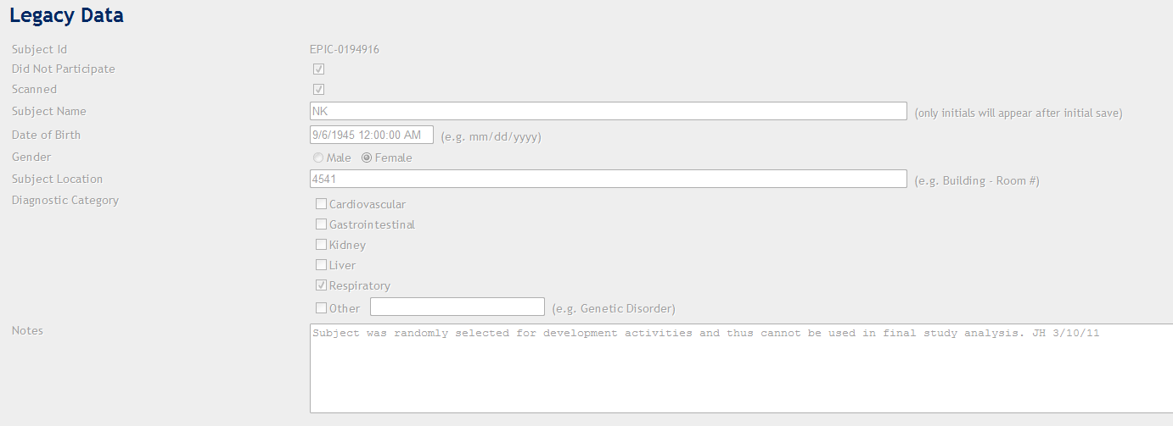
Figure 1

Verified Not Verified Non-Conformance Ref. No.

Verify that the Medical and Health Information in Figure 2 below is displayed for the subject.

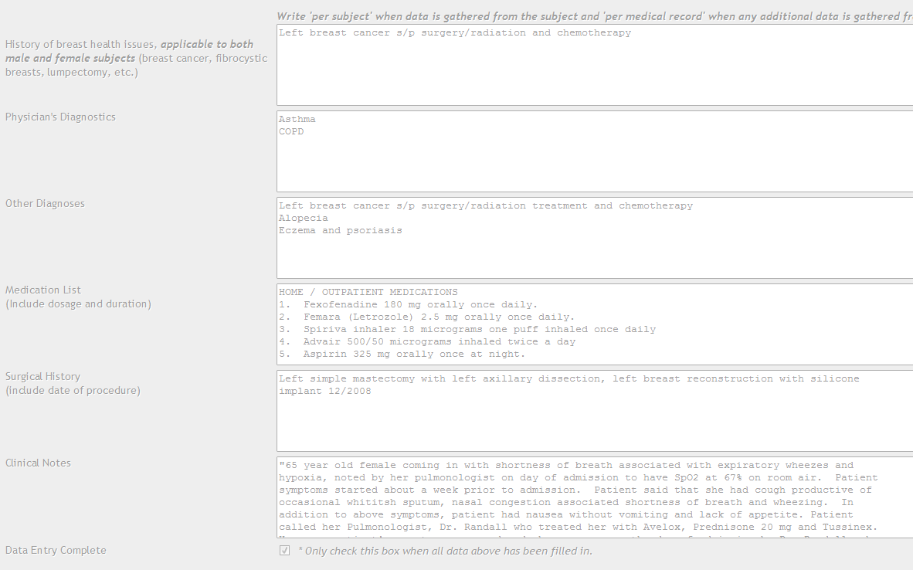
Figure 2

Verified Not Verified Non-Conformance Ref. No.

Summary/Completion page

Click the Search option at the bottom of the page. Enter EPIC-0068766 in the subject ID data entry box at the top of the Search page. Click the Either button and click the Search button. Click the line for EPIC-0068766 to open the record for viewing. Verify that the Demographics page is displayed and that the Subject ID, Subject Initials, Gender and Date of Birth are displayed at the top of the page.

Verified Not Verified Non-Conformance Ref. No.

Click to highlight the Summary/Completion page. A message may be displayed to inform you the Demographics page is not filled out properly. Click OK. Verify that a page opens displaying data points within each data entry page (e.g., Demographics, Recruitment/Scanning, Inclusion/Exclusion, etc.) .

Verified Not Verified Non-Conformance Ref. No.

- Scroll down to the bottom of the page and click the Save button. Scroll down the page and record the data entry page (i.e., Demographics, Recruitment/Scanning, Inclusion/Exclusion, etc.) and the actual data entry point (i.e., Gender, Ethnicity, etc.) all required fields with red error messages present on the Summary/Completion Verification Table below. Additional pages can be printed if necessary.
- Enter data for all required fields previously recorded in the Summary/Completion Verification Table below. Record the data entered (e.g., select an option from pull down menus and/or enter data as appropriate) in the appropriate location in the Summary/Completion Verification Table. Contact the Quality Assurance Manager and/or CTO for clarification of any data point entry requirement as necessary.
- Upon completion of all required data entry points, click the Save button at the bottom of the page. Click the Search option at the bottom of the page. Enter EPIC-0068766 in the subject ID data entry box at the top of the Search page. Click the Either button and click the Search button. Click the line for EPIC-0068766 to open the record for viewing. Click to highlight the Summary/Completion page. A message may be displayed to inform you the Demographics page is not filled out properly. Click the Save button at the bottom of the page.
- Verify that the data entered in step b above is no longer highlighted by a red error message. Record the results of this verification on the Summary/Completion Verification Table below.

Summary Completion Verification Table
Page | Data Point | Data Entered | Verified Saved | Non-Conformance

Summary Completion Verification Table
Page | Data Point | Data Entered | Verified Saved | Non-Conformance

Click the Search option at the bottom of the page. Enter EPIC-0068766 in the subject ID data entry box at the top of the Search page. Click the Either button and click the Search button. Click the line for EPIC-0068766 to open the record for viewing. Verify that the Demographics page is displayed and that the Subject ID, Subject Initials, Gender and Date of Birth are displayed at the top of the page.

Verified Not Verified Non-Conformance Ref. No.

Click to highlight the Summary/Completion page. A message may be displayed to inform you the Demographics page is not filled out properly. Click OK. Verify that a page opens displaying data points within each data entry page (e.g., Demographics, Recruitment/Scanning, Inclusion/Exclusion, etc.) .

Verified Not Verified Non-Conformance Ref. No.

    - Report function. This link allows the Clinical Coordinator to view a report that summarizes subject counts for various categories, including Diagnosis and Demographics information. The report can be modified for a date range based on the date the subject was initially entered into the database.

The report function must be verified by generating the report for three different data ranges- 4/3/11 to 4/9/11 (Labeled Data Set #1CC), 4/17/11 to 4/23/11 (Labeled Data Set #2CC) and 4/24/11 to 4/30/11 (Labeled Data Set #3CC). Click the Main Menu button at the bottom of the page. Click the Report button. Verify that the Report Screen is displayed.

Verified Not Verified Non-Conformance Ref. No.

Enter the first Start Date and End Date in the space provided. Click the Run button. Print the page by right clicking on the screen and selecting the Print option. Press the Print button on the Print Dialog window that is opened. Label the printout as Data Set #1CC.

Verify that the printout matches the totals on the display screen.

Data Set #1CC Verified Not Verified Non-Conformance Ref. No.

Repeat these steps as necessary to generate each of the remaining two data sets (i.e., date ranges). Print and label appropriately.

Data Set #2CC Verified Not Verified Non-Conformance Ref. No.

Data Set #3CC Verified Not Verified Non-Conformance Ref. No.

Verification of Reported Totals

Click the Main Menu button at the bottom of the page. Click the Search Subject Records menu item. Click the Either radial button and click the Search button. Use the sort function at the top of the column Entered to sort by the date entered. Locate the subject records for each week reported. Open each subject record whose Entered date falls within the range of the date for the CC#1 report. Record the Subject ID on the back of the form for Participated and Did Not Participated. For subjects who did not participate, do not proceed with the further tallys. For all subjects that do not have the Did Not Participate checkbox marked, record the Subject IDs next to each report section in which they would properly fall. For example, if subject EPIC-00001 had the Cardiovascular Qualifying diagnosis checked, was entered on 4/4/11, Gender was Male, Age range was 50-59, and Ethnicity was Asian, record EPIC-00001 next to the Subject Count for Cardiovascular, Male, 50-59, and Asian on the printout of CC#1. After all subjects with Entered dates within the CC#1 sample report dates have been recorded, tally each reported count. Record the results of the verification (i.e., if the reported count matches the total number of subject ids recorded, check Yes) in the table below.

Report Verification
Data Set | Printout Verified | Count Verified |  | Initials | Non-Conformance Reference Number
Data Set #1 | □Yes □No | Total Scanned | □Yes □No
Data Set #1 | □Yes □No | Subjects Participated | □Yes □No
Data Set #1 | □Yes □No | Adverse Events | □Yes □No
Data Set #1 | □Yes □No | Count of Diagnosis | □Yes □No
Data Set #1 | □Yes □No | Count by Week | □Yes □No
Data Set #1 | □Yes □No | Count by Gender | □Yes □No
Data Set #1 | □Yes □No | Count by Age | □Yes □No
Data Set #1 | □Yes □No | Count by Ethinicity | □Yes □No
Data Set #2 | □Yes □No  Initials: | Total Scanned | □Yes □No
Data Set #2 | □Yes □No  Initials: | Subjects Participated | □Yes □No
Data Set #2 | □Yes □No  Initials: | Adverse Events | □Yes □No
Data Set #2 | □Yes □No  Initials: | Count of Diagnosis | □Yes □No
Data Set #2 | □Yes □No  Initials: | Count by Week | □Yes □No
Data Set #2 | □Yes □No  Initials: | Count by Gender | □Yes □No
Data Set #2 | □Yes □No  Initials: | Count by Age | □Yes □No
Data Set #2 | □Yes □No  Initials: | Count by Ethinicity | □Yes □No
Data Set #3 | □Yes □No  Initials: | Total Scanned | □Yes □No
Data Set #3 | □Yes □No  Initials: | Subjects Participated | □Yes □No
Data Set #3 | □Yes □No  Initials: | Adverse Events | □Yes □No
Data Set #3 | □Yes □No  Initials: | Count of Diagnosis | □Yes □No
Data Set #3 | □Yes □No  Initials: | Count by Week | □Yes □No
Data Set #3 | □Yes □No  Initials: | Count by Gender | □Yes □No
Data Set #3 | □Yes □No  Initials: | Count by Age | □Yes □No
Data Set #3 | □Yes □No  Initials: | Count by Ethinicity | □Yes □No

  - Data Export Function. This link allows the user to export data from the Clinical Trial Data Collection database to a separate file.

    - Please Log In function. This window provides the user a method to enter their user name and password in order to access the web form application.

Click in the User Name box and enter “biostats”. Click in the password box and enter “ad.” Click the Log In button. Verify that a red message appears saying “Invalid Login,” the User Name box contains “admin,” and the Password box is empty.

Verified Not Verified Non-Conformance Ref. No.

Click in the User Name box and enter “biostats”. Click in the password box and enter “bio1337”. Click the Log In button. Verify that the Main Menu with the Data Export and Logout links appears as below:
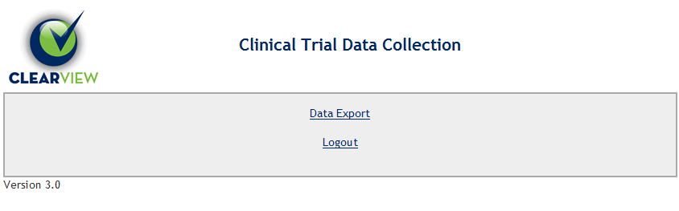
Verified Not Verified Non-Conformance Ref. No.

    - Logout Function. Click on the Logout link. Verify that the Log In screen reappears.

Verified Not Verified Non-Conformance Ref. No.

Login as “biostats” using the information from Section 6.3.1.

    - Data Export Function. Click on the Data Export link. Verify that the Export screen opens.

Verified Not Verified Non-Conformance Ref. No.

Verify that all of the checkboxes are checked. Click the Data Export button. Verify that the Export Screen is displayed (NOTE: The amount of data listed in the Export Log and the Row count downloaded will be different every time the Export is performed).

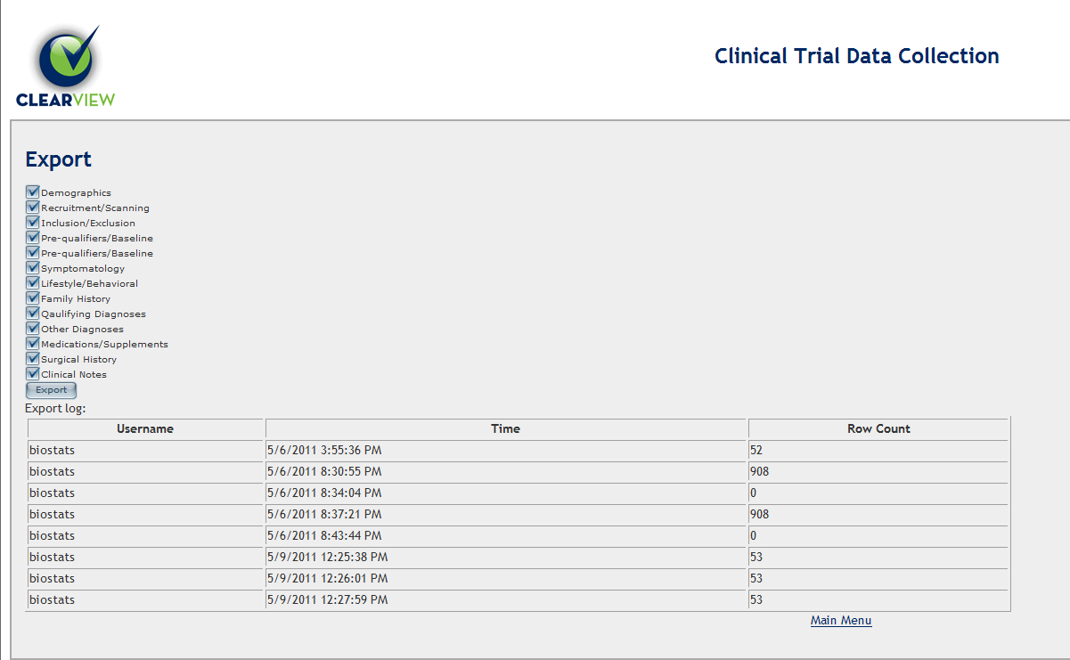

Verified Not Verified Non-Conformance Ref. No.

Click the Export button. Verify that a File Download window is displayed.

Verified Not Verified Non-Conformance Ref. No.

Click the Save button to save the zip file to a local directory. Save the zip folder. Click on the Data Export link. Verify that a new row was added to the Export log with the correct date and time and a row count greater than 0.

Verified Not Verified Non-Conformance Ref. No.

Locate the zip folder on the local directory. Open the zip folder and extract the csv files for use in the verification. Verify that the following list of csv files are downloaded:

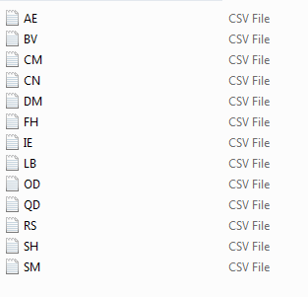
Verified Not Verified Non-Conformance Ref. No.

Open the first file. Randomly select three subject IDs and record in the table below. In the Clinical Trial Webform, logout and login as CC1 using the password “password”. Locate the three records identified and verify the data exported in the csv file matches the data displayed in the Webform. Check the “Yes” box if the data matches and the “No” box if the data doesn’t match. Continue opening files and selecting subject IDs and verifying the data downloaded until all files have been evaluated.

Export Data Verification
File Name | Subject IDs | Data Verified | Initials | Non-Conformance Reference
AE |  | □Yes □No
BV |  | □Yes □No
CM |  | □Yes □No
CN |  | □Yes □No
DM |  | □Yes □No
FH |  | □Yes □No
IE |  | □Yes □No
LB |  | □Yes □No
OD |  | □Yes □No
QD |  | □Yes □No
RS |  | □Yes □No
SH |  | □Yes □No
SM |  | □Yes □No
Click the Main Menu button and click Logout. Login using the Biostats name and password previously provided. Click the Export button. Click to uncheck all of the checkboxes. Click the Export button. Verify that a File Download dialog box opens. Click the Cancel button. Verify that the dialog box closes.

Verified Not Verified Non-Conformance Ref. No.

Click the Main Menu link at the bottom of the page. Click on the Data Export link. Verify that a new row was added to the Export log with the correct time and a row count of 0.

Verified Not Verified Non-Conformance Ref. No.

Click on the Main Menu link. Click on the Logout link. Verify that the Log In screen reappears.

Verified Not Verified Non-Conformance Ref. No.

- Reference
EG-011, Software Validation
QA-004, Deviations
CS-003, Customer Feedback

- Attachments
Attachment A, Deviations from Protocol
Attachment B, Non-conformances Worksheet

Attachment A
Deviations from Protocol
NOTE: This form is used for minor deviations from the protocol as written. Fill out all sections of this form prior to moving forward in the validation process.

No. | Date | Name | Description of Deviation (include reference to the protocol section) | Resolution/Action Taken | Reviewed

Attachment B
Non-conformances Worksheet
NOTE: This form is used for all protocol steps which did not perform as expected. Fill out all sections of this form prior to moving forward in the validation process.
No. | Date | Name | Description of Non-conformance (include reference to the protocol section) | Resolution/Action Taken

